SQL Server 2022: CALUMO
Master Document &
User Manual
Dated: March 26th ’24.
Contents
Introduction 3
Executive Summary 3
Benefits 4
New features relevant to CALUMO 4
Environment Setup 5
Compatibility Review 5
Baseline Metrics and Performance 5
Performance Testing 5
Technical Summary 10
Preliminary Technical Test scenarios 10
Functional Summary 13
Overall Summary 40

Introduction
This report outlines the objectives and rationale for the proposed upgrade of CALUMO's reporting infrastructure to Microsoft SQL Server 2022. The aim is to evaluate the upgrade's implications for system performance, compatibility, and feature enhancement to ensure that the transition supports our strategic goals and maintains our commitment to technological excellence.
Currently, CALUMO is certified to operate on SQL Server 2019. With Microsoft phasing out mainstream support for SQL Server 2019 by February 2025, there is a need to transition to the more modern and supported platform. SQL Server 2022 offers extended support and additional features that help optimize processing and operations.

Executive Summary
This report presents a consolidated overview of the outcomes from the evaluation and impact analysis conducted to determine the suitability of CALUMO for operation with Microsoft SQL Server 2022. This assessment was driven by the need to address Customer requests, stay ahead of the end of mainstream support for SQL Server 2019 and to leverage the advanced features and performance enhancements offered by the latest SQL Server version.

The approach was multi-staged, encompassing both pre-migration and post-migration activities. The pre-migration phase involved setting up a test environment that mirrors the production setup, which included hardware, SQL Server configuration, and network settings. Critical to this phase was the review and adaptation to the 'Deprecated' and 'Discontinued' features specific to SQL Server 2022 to avoid any compatibility issues post-upgrade.

Post-migration testing was aimed at validating the performance metrics against the baseline to identify any regressions or improvements. Findings were promising, showing a high compatibility between SQL Server 2019 and 2022, with notable performance upticks in query execution and the efficiency of in-memory operations. For instance, certain operations that took six seconds in SQL 2019 were completed in under a second in SQL 2022.

Testing found SQL Server Native Client has been deprecated in SQL Server 2019 and is absent in SQL Server 2022. Moving forward, connections must be made using the updated Microsoft OLE DB Driver for SQL Server or the latest Microsoft ODBC Driver.

The upgrade to SQL Server 2022 presents an opportunity for performance optimisation and the utilisation of new features. This report recommends the endorsement of SQL Server 2022 for operation in CALUMO environment and endorses its implementation, ensuring that customers can utilise the latest features.

Benefits
CALUMO heavily utilizes ColumnStore, In-Memory OLTP, tempdb, and frequently executes complex queries that historically could result in suboptimal performance. Microsoft SQL Server 2022 has introduced substantial improvements in these areas, reflecting a direct translation of Microsoft's insights from operating Azure SQL Database with a vast customer base. This extensive usage has provided a wealth of telemetry data, enabling Microsoft to address even the most uncommon issues in the newest versions.

New features relevant to CALUMO
- System page latch concurrency enhancements benefit all user databases, particularly improving performance for workloads that are heavy on tempdb usage.
- Improved ColumnStore segment elimination has been marked as a critical update, given CALUMO's extensive use of columnstore indexes. This enhancement can notably accelerate certain query types, potentially leading to dramatic performance gains.
- In-memory OLTP improvements align with CALUMO's substantial use of in-memory tables, promising to boost efficiency in this area.
- Instant file initialization for transaction log file growth events will support CALUMO's frequent bulk ETL processes, which typically cause transaction log files to expand.
- Reduced buffer pool I/O promotions serve to enhance storage performance across all databases, contributing to overall system efficiency.
- Enhanced spinlock algorithms aim to improve performance across the board for all databases.
- Query Store Memory grant feedback is set to optimise memory usage and address spills to tempdb, a known challenge within data warehouse queries that CALUMO encounters.
- Parameter-sensitive plan optimization and Degree of parallelism (DOP) feedback are highlighted as particularly impactful. These features eliminate the need for manual restrictions on parallelism in queries, which has previously led to underutilization of available vCPUs due to performance concerns. With this advancement, CALUMO can expect queries to run up to 2-3 times faster as most can now fully utilize the 32 vCPUs in the new VM environment. Simultaneously, it restricts only those queries that could potentially cause problems, providing an intelligent, automated tuning process.
- Cardinality estimation feedback will address and rectify inefficient query execution plans that repeat queries, especially beneficial to CALUMO's data warehouse scenarios where varying data set sizes can affect performance.
- Optimized plan forcing is relevant for databases that execute complex query plans, a common occurrence in CALUMO's operations.
- MDX Fusion, an optimization technique, will decrease the number of storage I/O requests for each Analysis Service cube query, streamlining the data retrieval process.

Environment Setup
The testing environment for CALUMO's upgrade to Microsoft SQL Server 2022 was configured to simulate a production setting, ensuring a reliable basis for performance comparison. The hardware, DBs and network configurations were mirrored. In preparation for SQL Server 2022, we noted SQL Server Native Client has been deprecated in SQL Server 2019 and is absent in SQL Server 2022. Moving forward, connections must be made using the updated Microsoft OLE DB Driver for SQL Server or the latest Microsoft ODBC Driver.

Compatibility Review
The compatibility review revealed that SQL Server Analysis Services (SSAS) 2022 has retired specific compatibility levels, notably Tabular 1100 and 1103. Despite these discontinuations, the review concluded that CALUMO does not utilize these features, such as the Tabular Model, Data Mining, and Power Pivot, thereby averting potential compatibility issues.

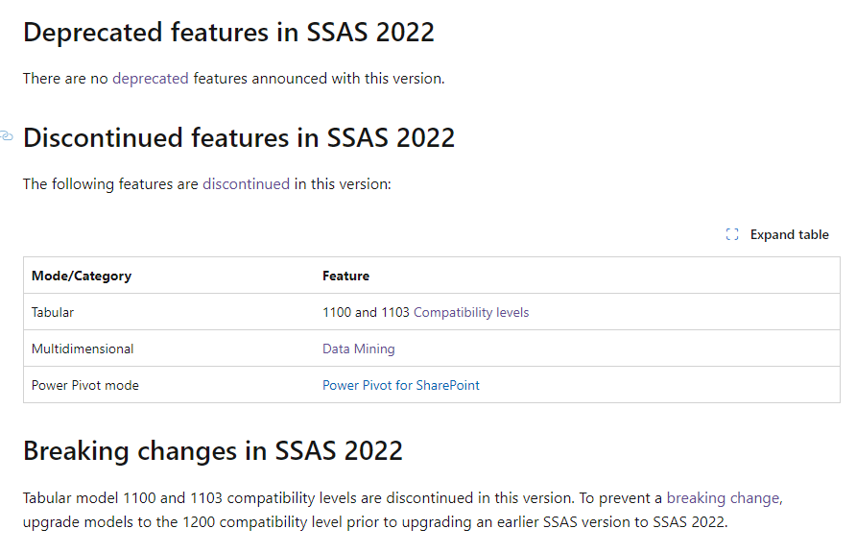

Baseline Metrics and Performance
Baseline metrics were recorded against SQL 2019, revealing speed improvements in large queries post-upgrade. These initial metrics serve as a benchmark to measure the enhanced performance capabilities offered by SQL Server 2022.

Performance Testing
Performance testing focused on areas where CALUMO's use is extensive and SQL Server 2022 has significant improvements: ColumnStore Indexes, In-Memory OLTP, Tempdb, and Complex Queries. In SQL Server 2022, these areas have benefited from enhancements derived from telemetry data accumulated from Azure SQL, reflecting over three years of product advancements compared to SQL Server 2019. Key features impacting performance, such as system page latch concurrency enhancements and improved ColumnStore segment elimination, showed that operations in SQL 2022 (under 1 second) were completed more quickly and efficiently than in SQL 2019 (6 seconds).

ColumnStore Test - SQL 2019: 00:00:06
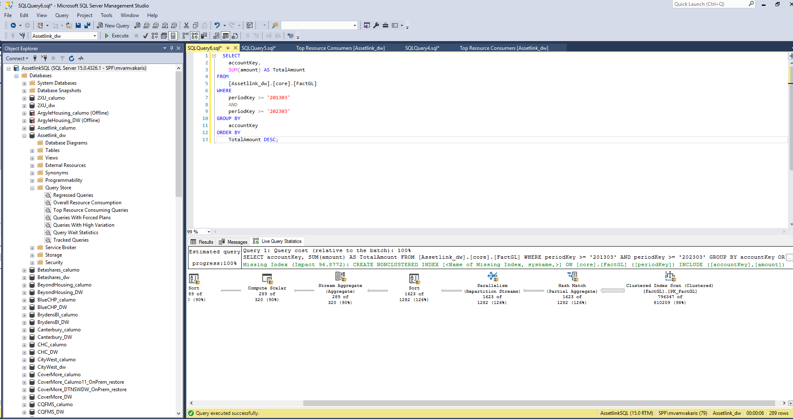

ColumnStore Test - SQL 2022: 00:00:00
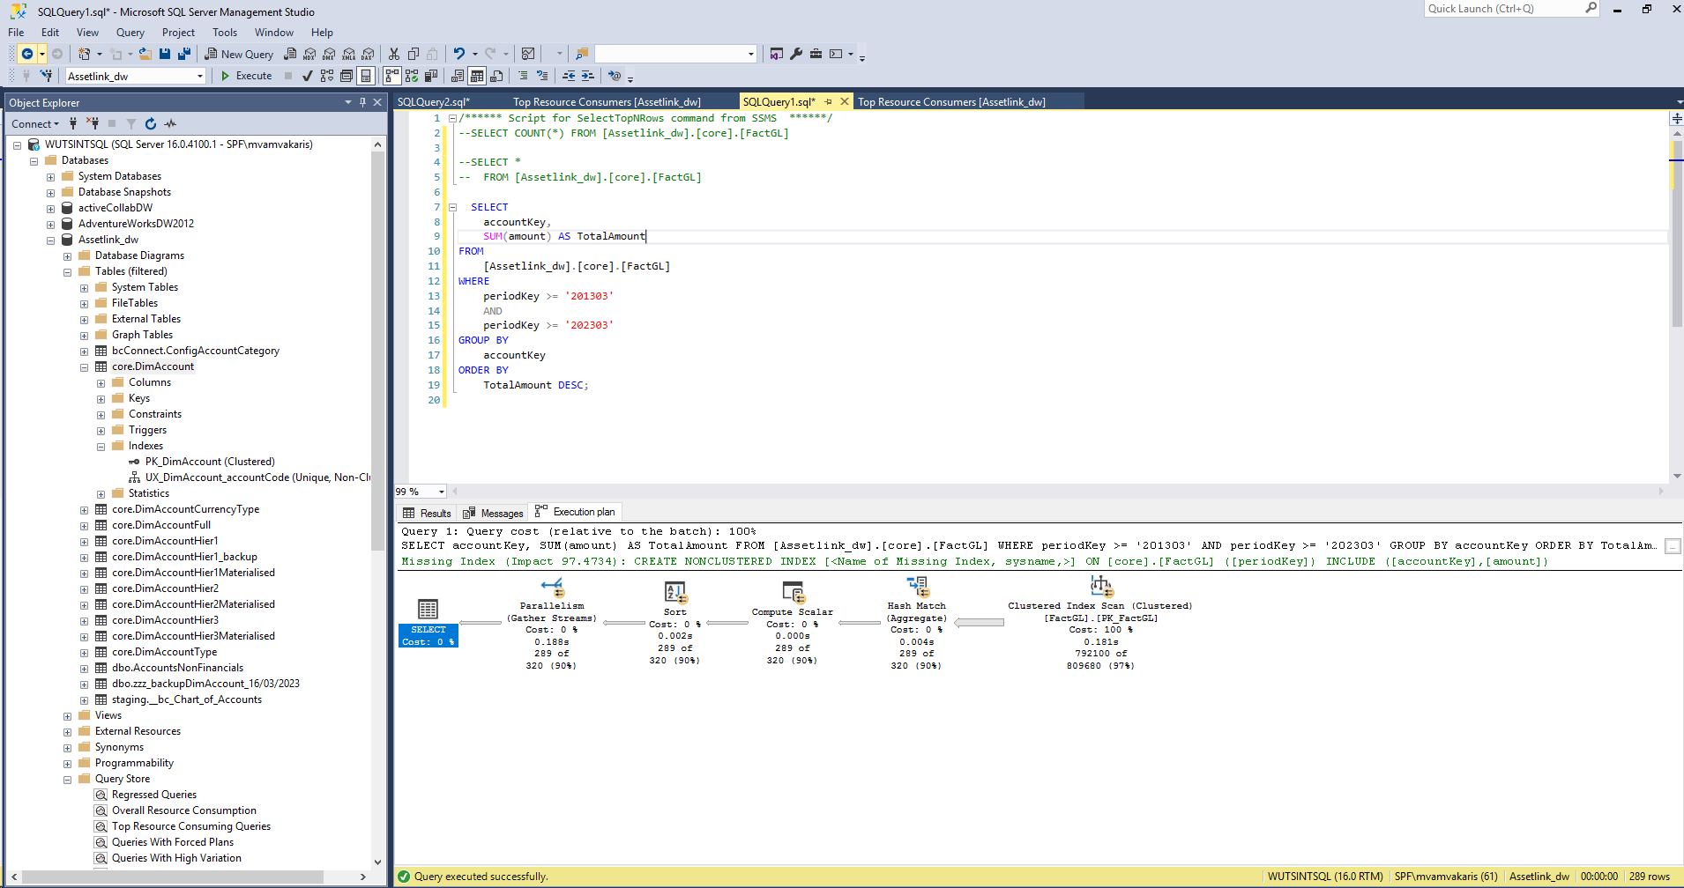

MDX Fusion Test – SQL 2019: 00:00:42
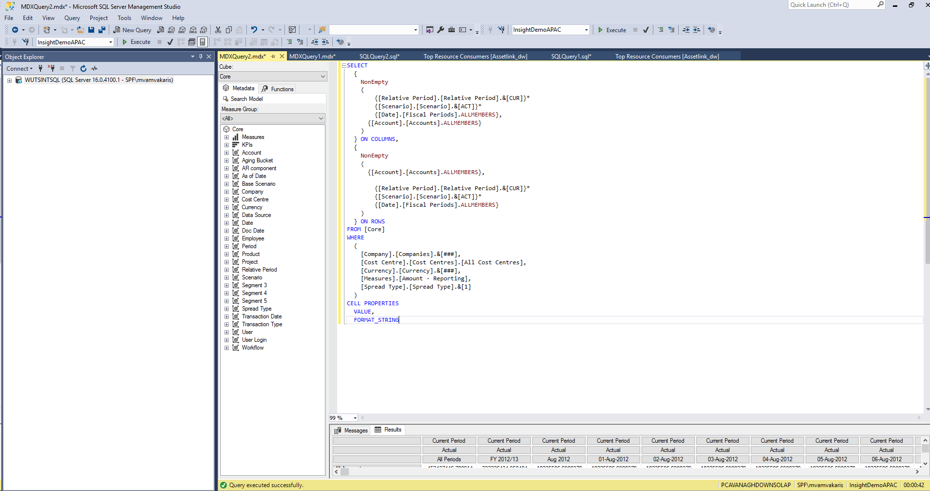

MDX Fusion Test – SQL 2022: 00:00:30
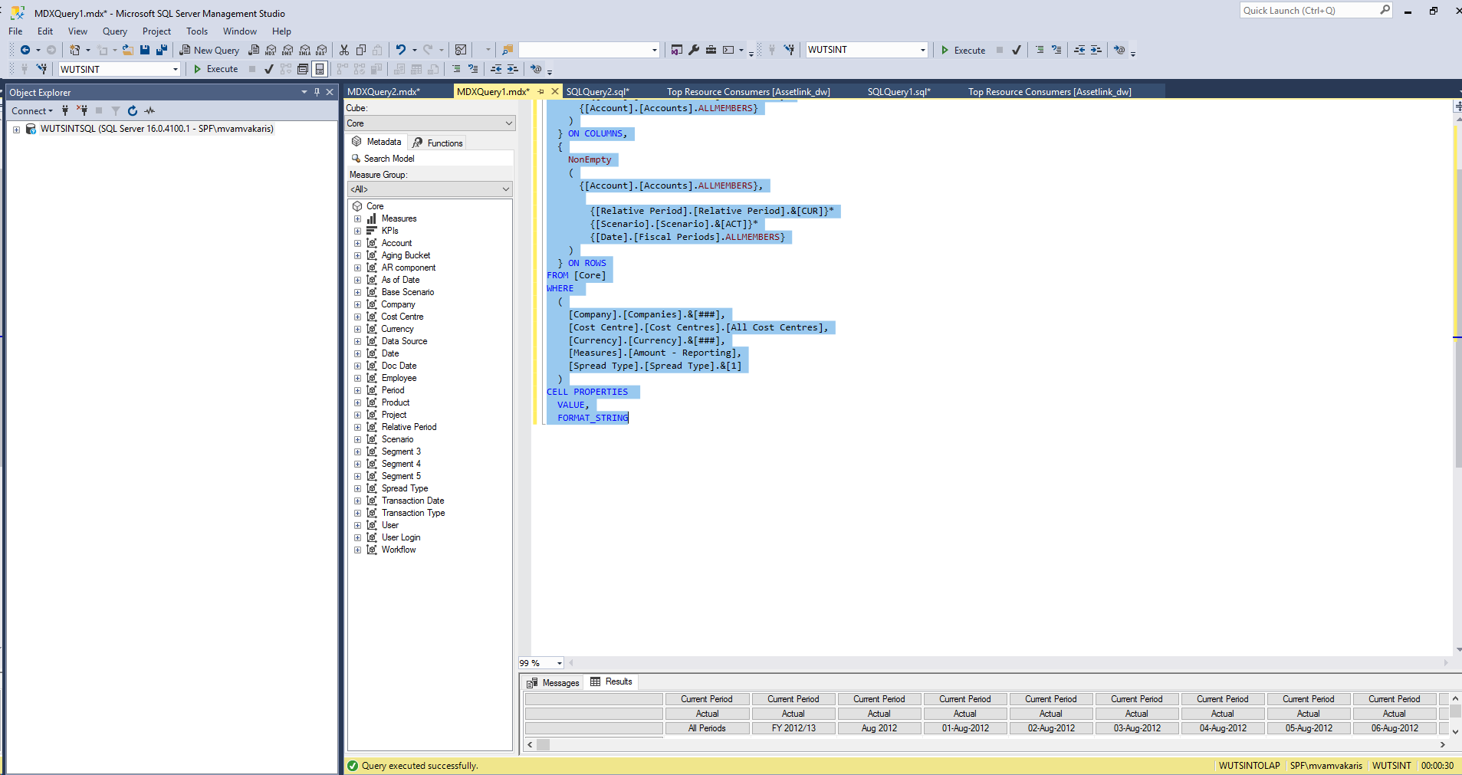
Large Query Test – SQL 2019: 00:01:15
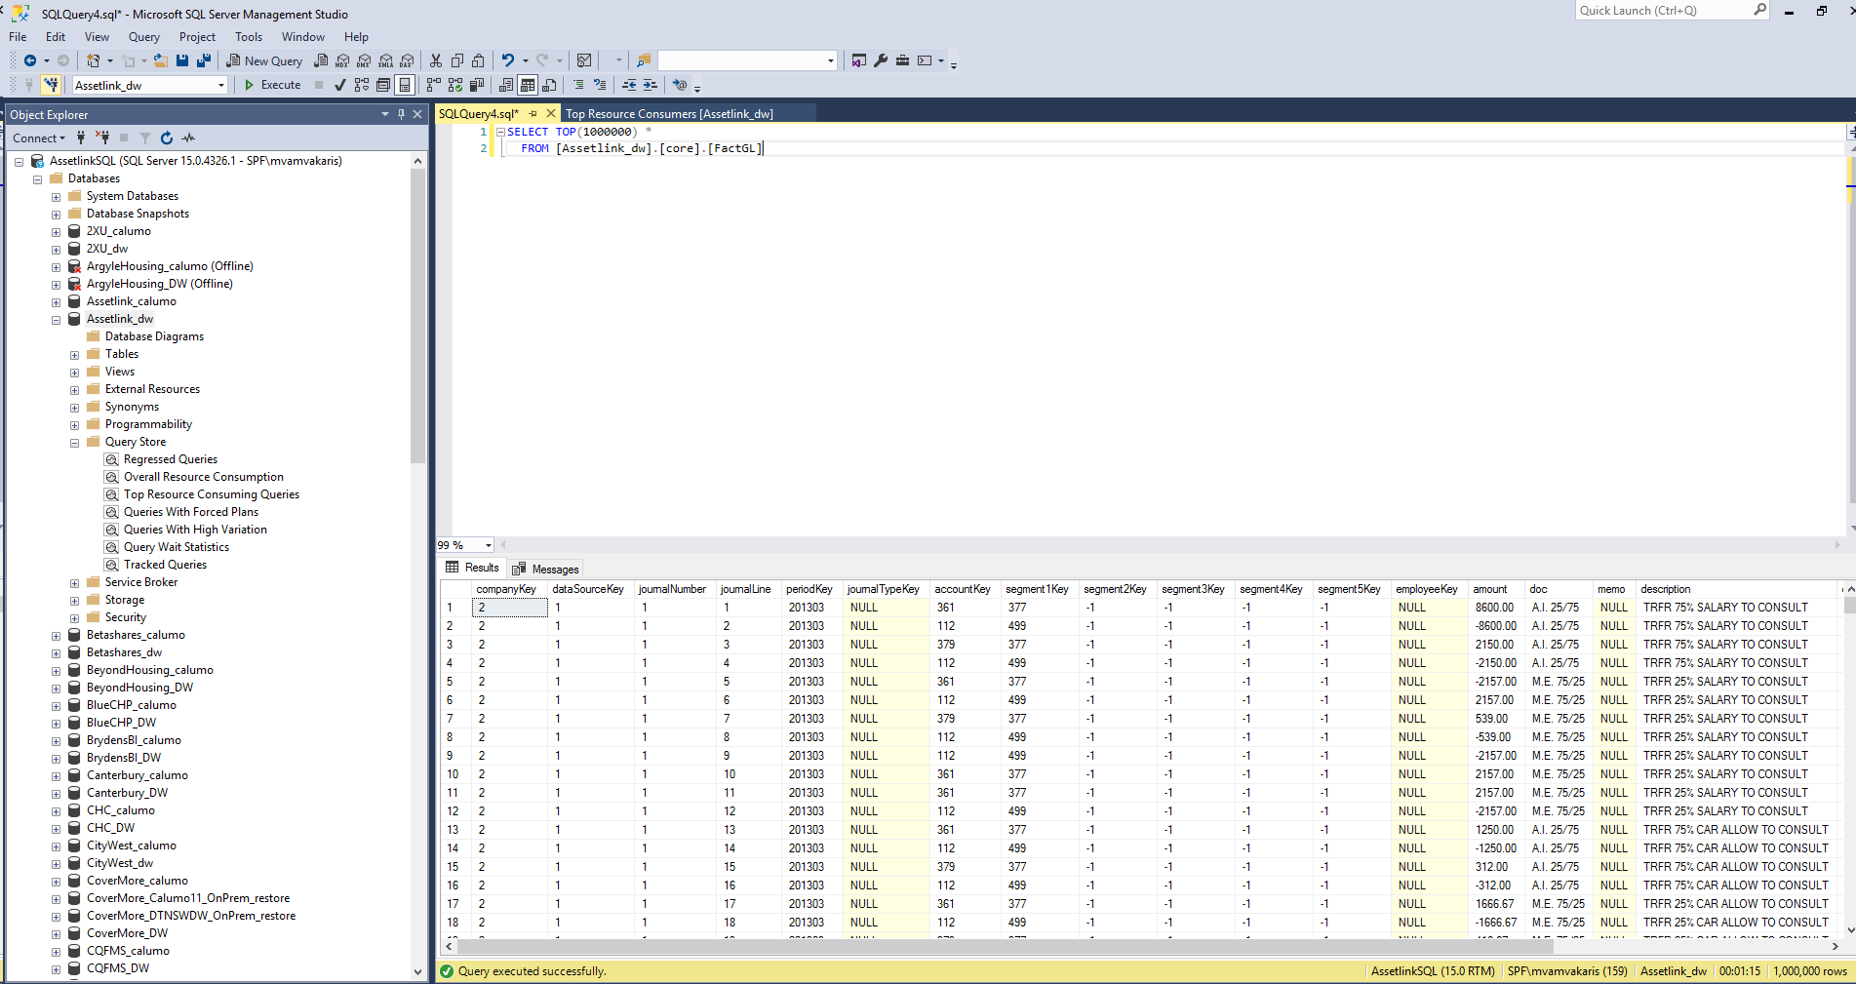

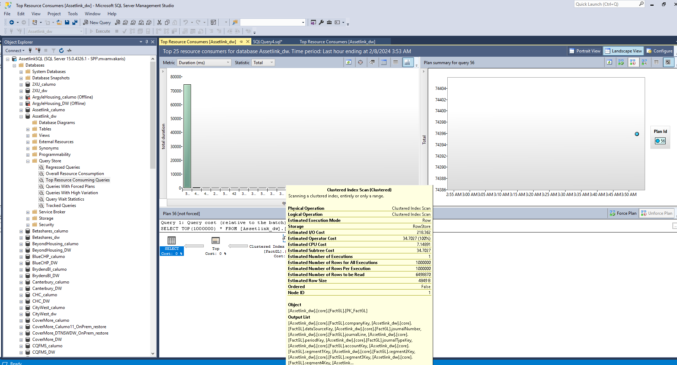

Large Query Test – SQL 2022: 00:01:12
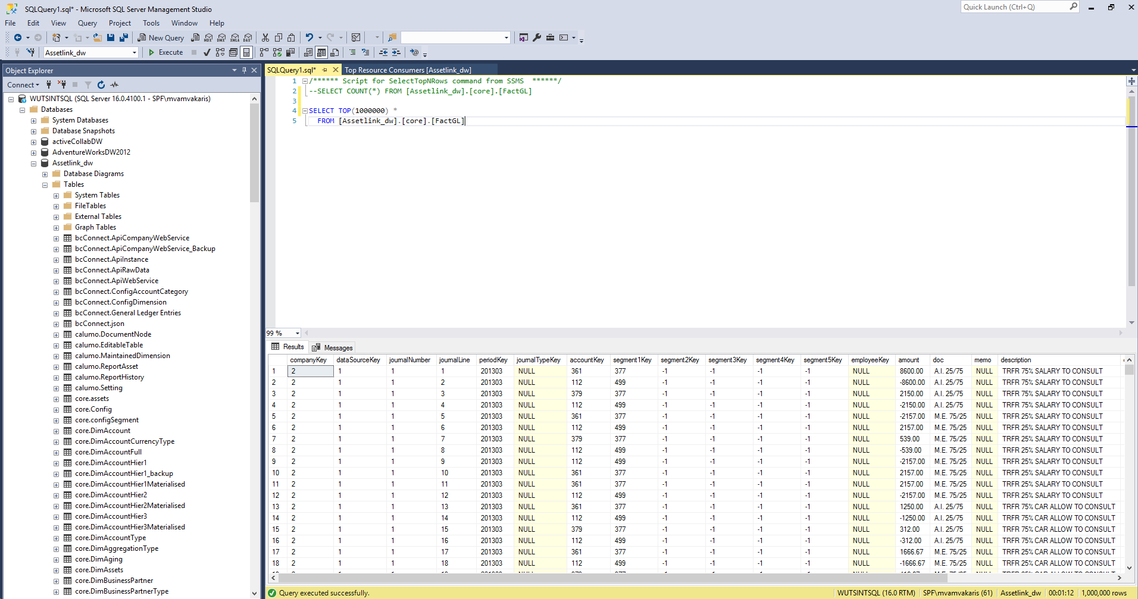

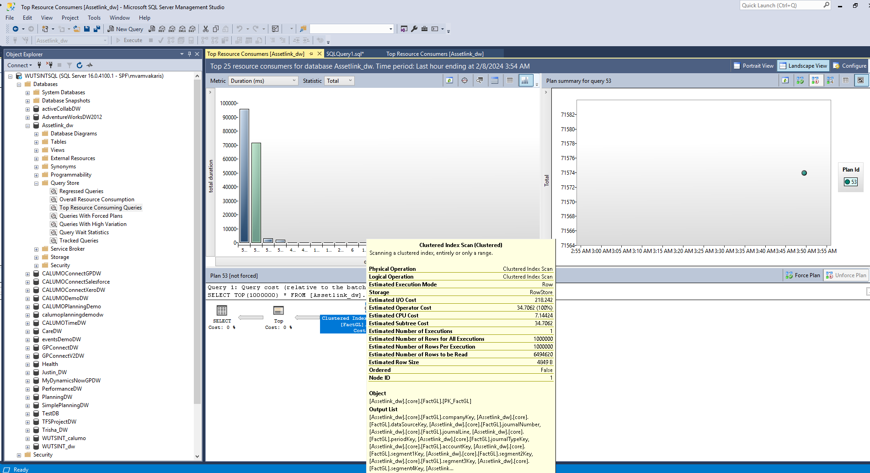
Report Load Test – SQL 2019: Average (0.53 seconds)
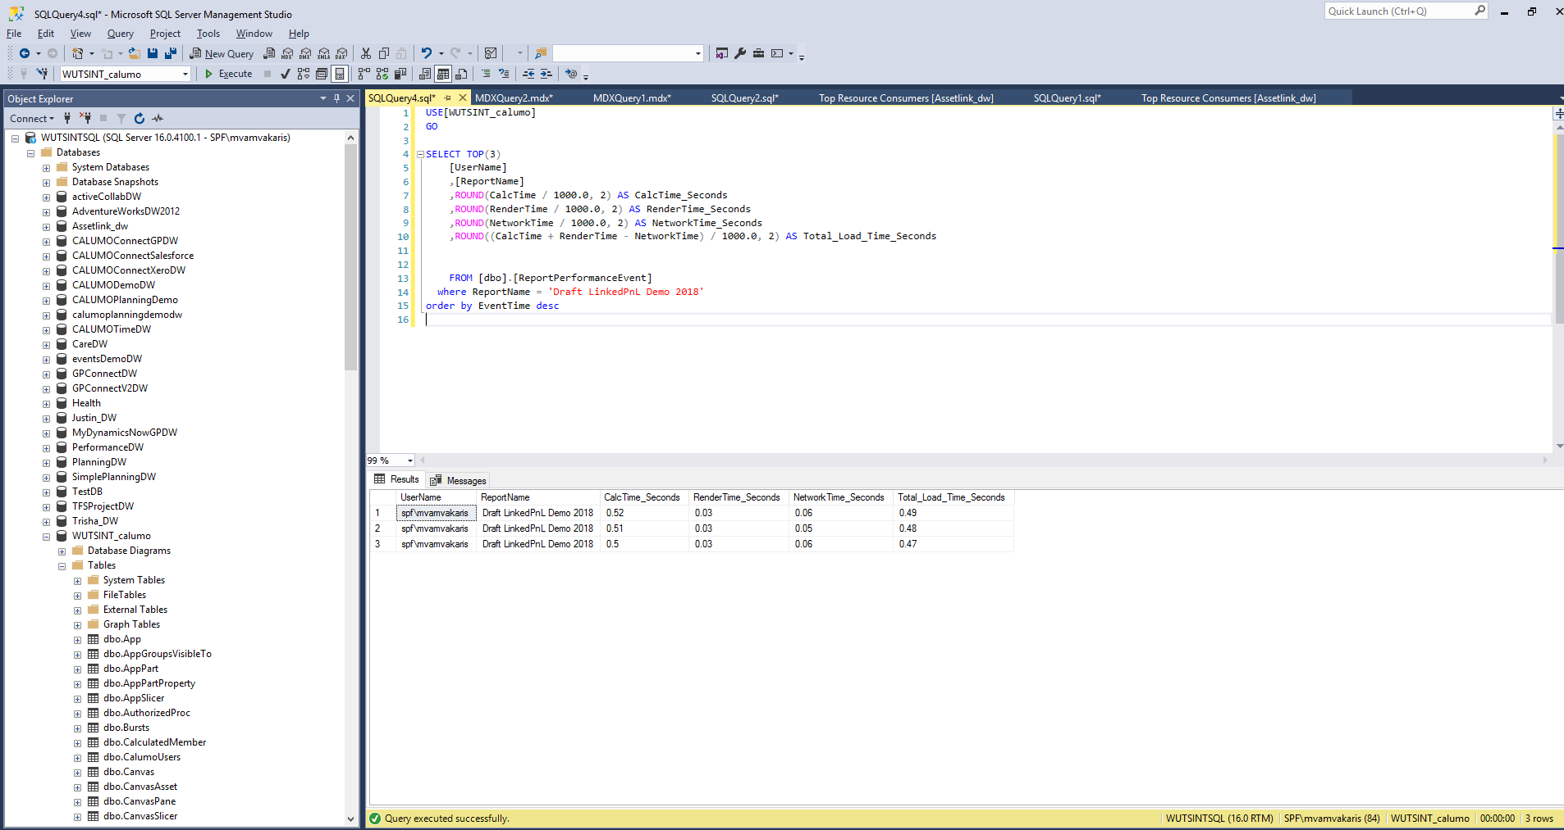

Report Load Test – SQL 2022: Average (0.48 seconds)

Technical Summary
With the help of DevOps team, a new environment was created with SQL 2022 and current Calumo application. First application loading and data intensive pages are investigated. The focussed testing of CALUMO component interacting with SQL did not reveal any unexpected behaviour. The set of testing performed by developers are listed in sections below.
In conclusion:
- The new application deployment did not face any error or trouble connecting servers.
- No error or any anomaly in CALUMO component behavior interacting with SQL server.
- There is no code change requirement identified to adapt the SQL 2022 version.
.

Preliminary Technical Test scenarios
With focus on components interacting with SQL server below pages were tested and found to be working fine.
- Data tab along with slicers working fine
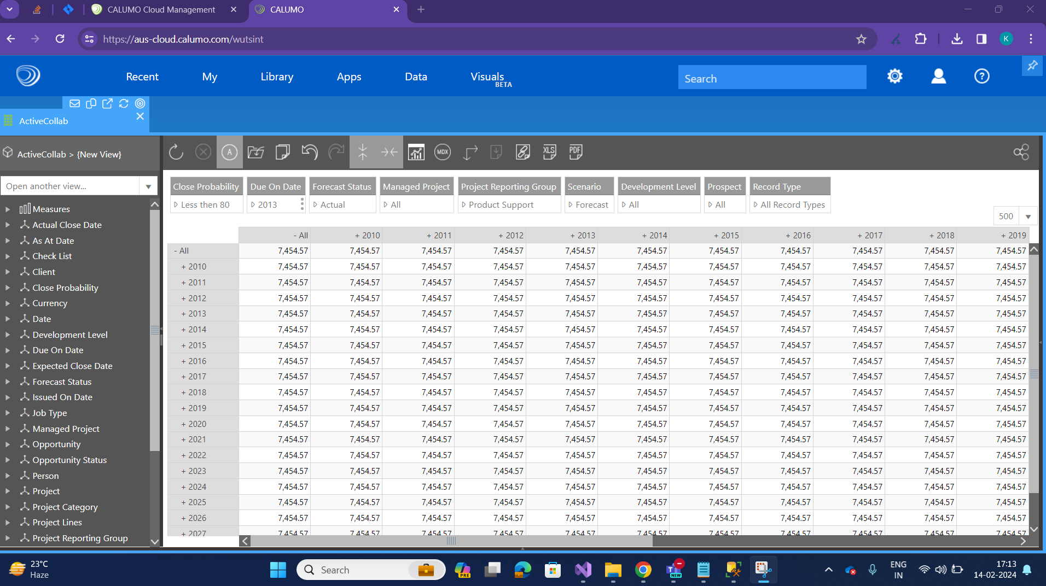
- Member Explorer
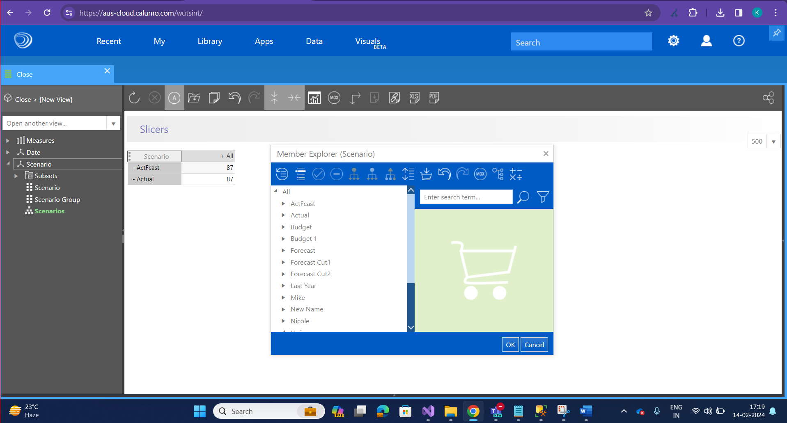
- Apps working fine
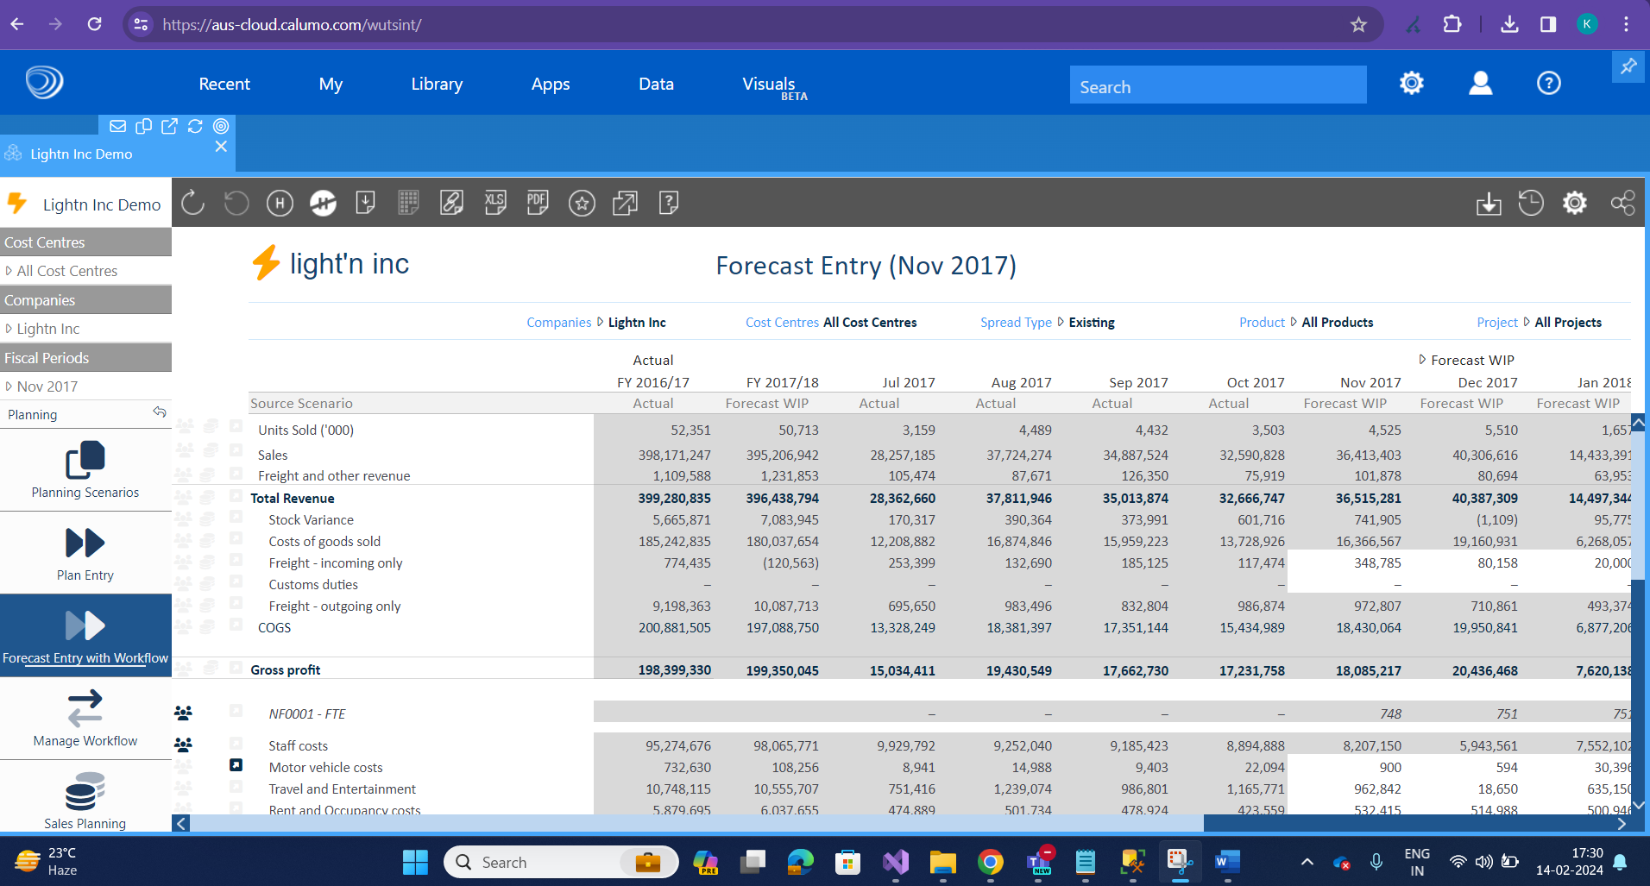
- Reports with charts are working fine.
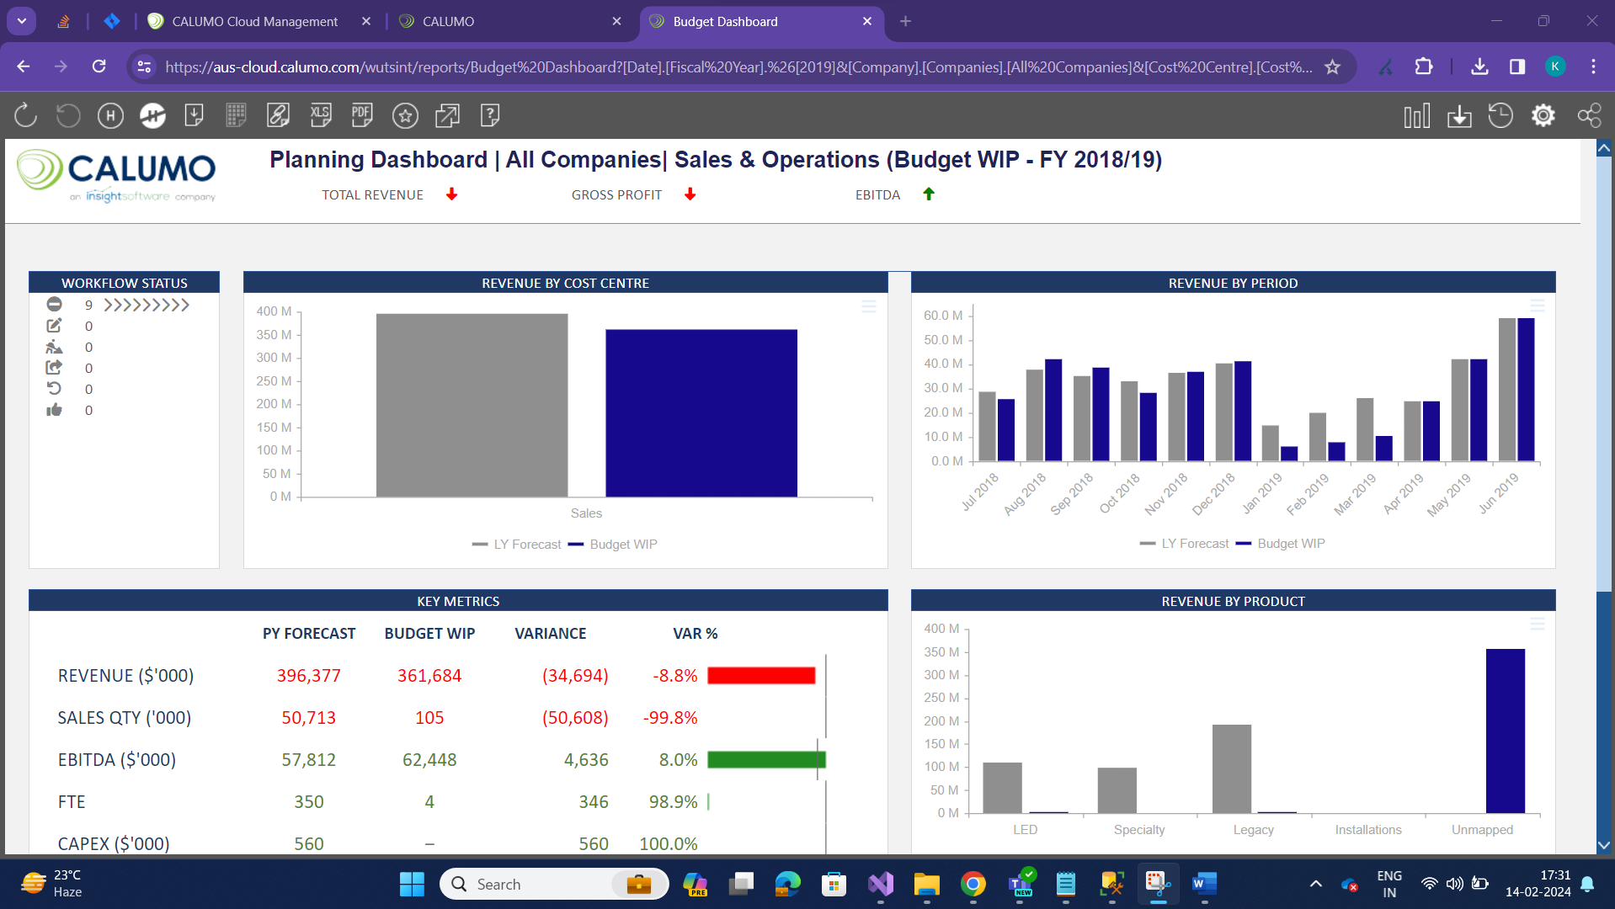
- PDF publications working fine.
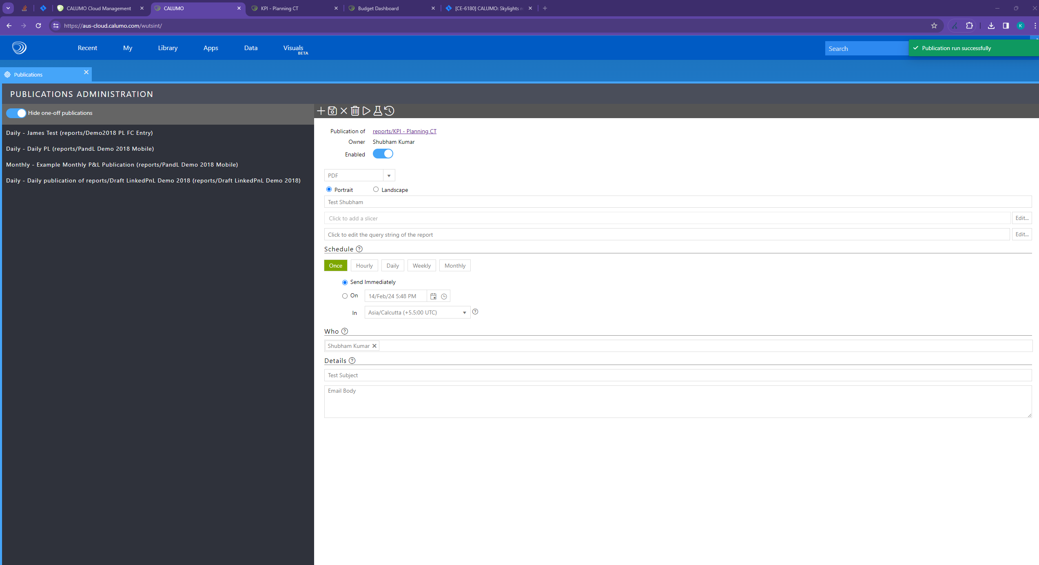
- Editable Tables are working fine
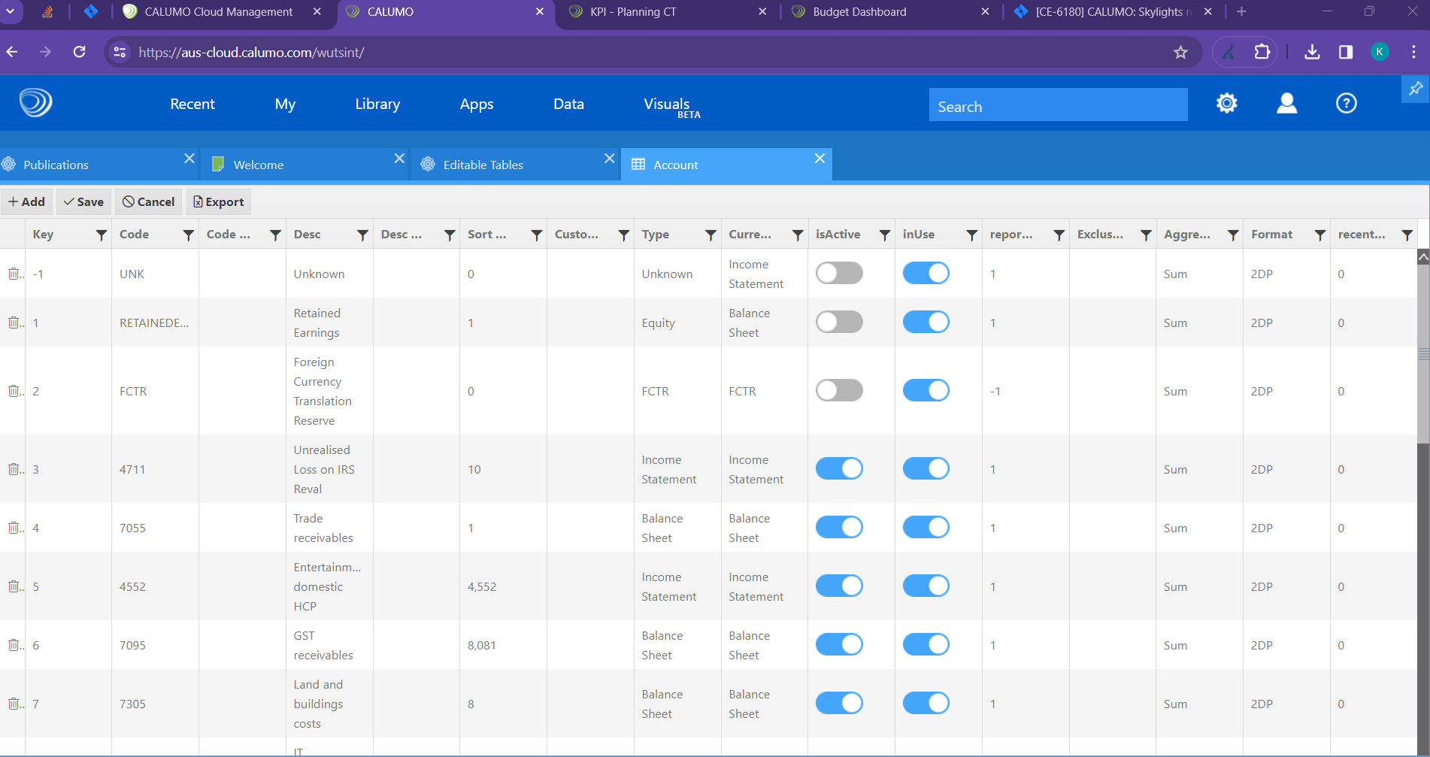

Functional Summary
As established practice once developers find the application working to their expectation quality assurance engineers were handed over to responsibility to validate there is no behavioral change in any portion of application due to unforeseen reasons. Below are the pages and flows tested and verified as part of quality assurance testing of application to ensure application functionality is unchanged.
In conclusion:
- No issues identified as part of these testing.

- Testing of Data tab:
https://aus-cloud.calumo.com/wutsint/HomeNew/home/View?datasource=SSAS&catalog=AdventureWorks2&cube=Adventure%20Works&viewId=
Able to load dimension data, row wise and column wise
Able to load data with slicers.
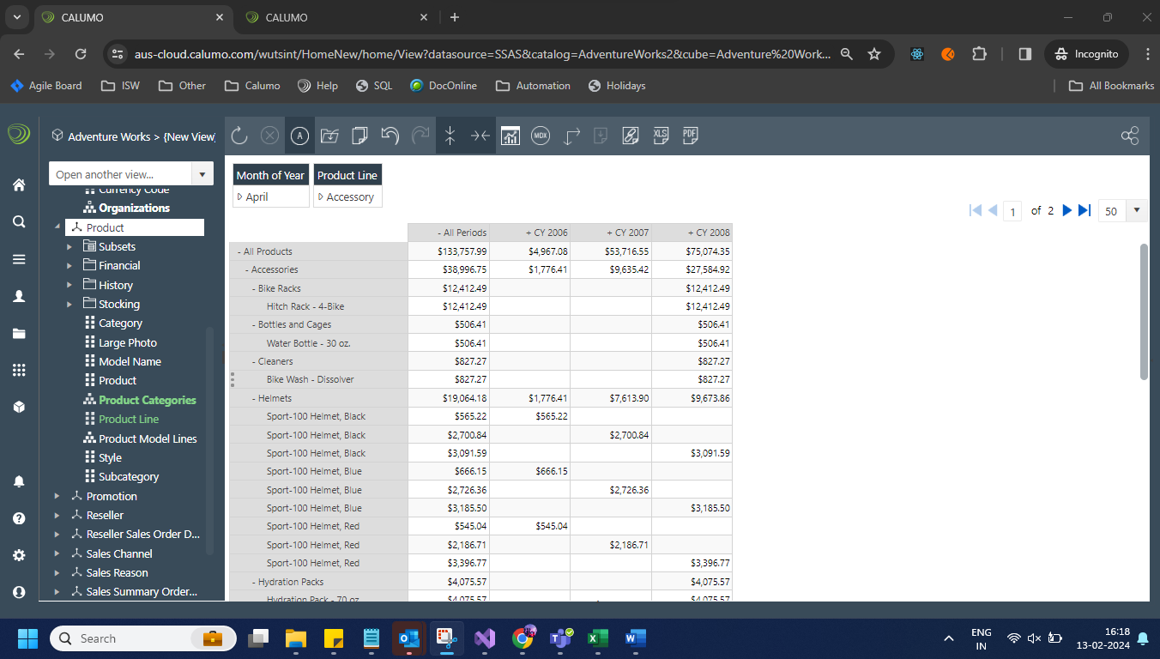
  - Able to save the view and able to see in the data list:
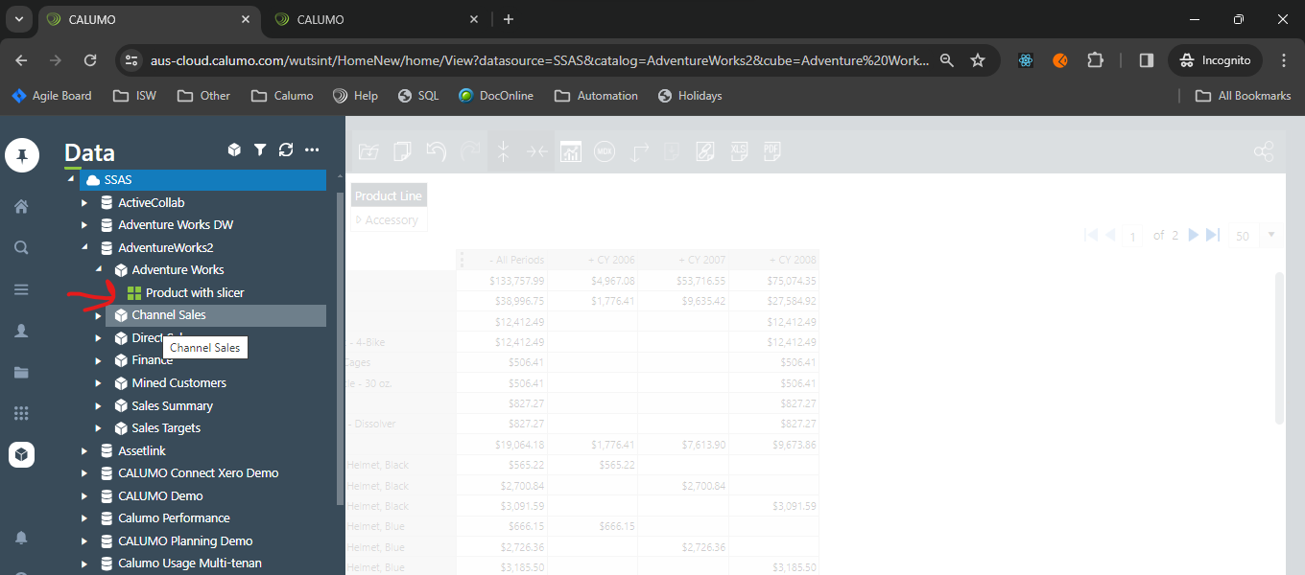
  - Able to open the saved view: https://aus-cloud.calumo.com/wutsint/HomeNew/home/View/409
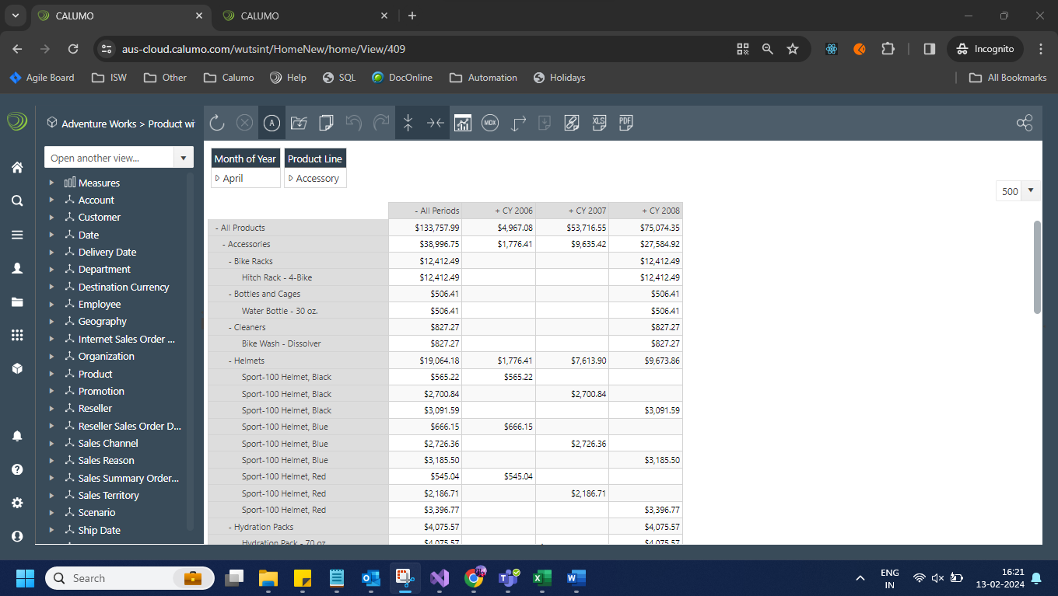
  - Able to convert View to chart:
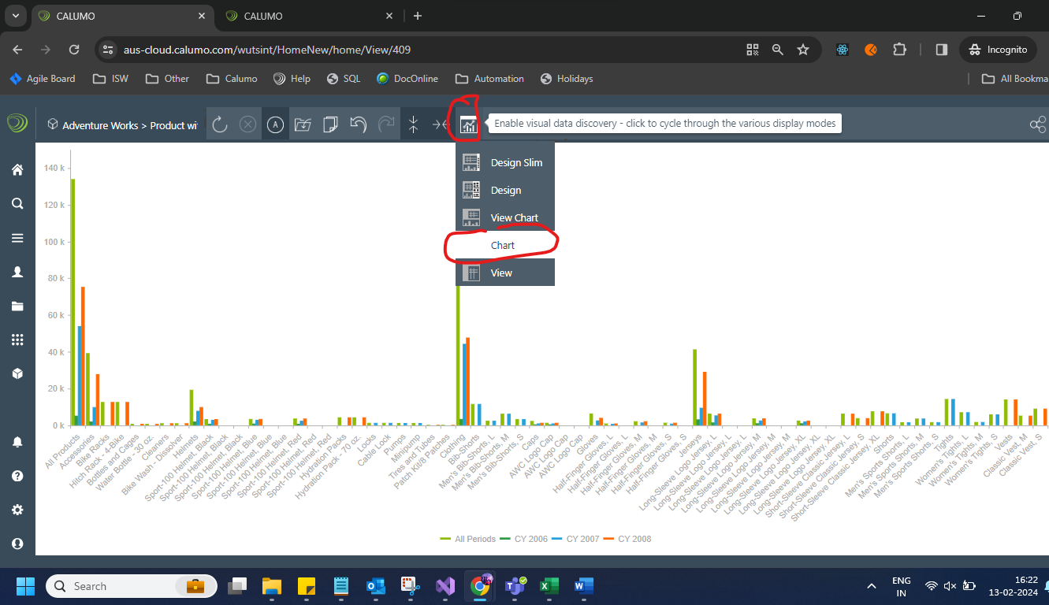

  - Able to download the view as Excel and PDF

  - Able to load CCHART in excel for the earlier saved view:
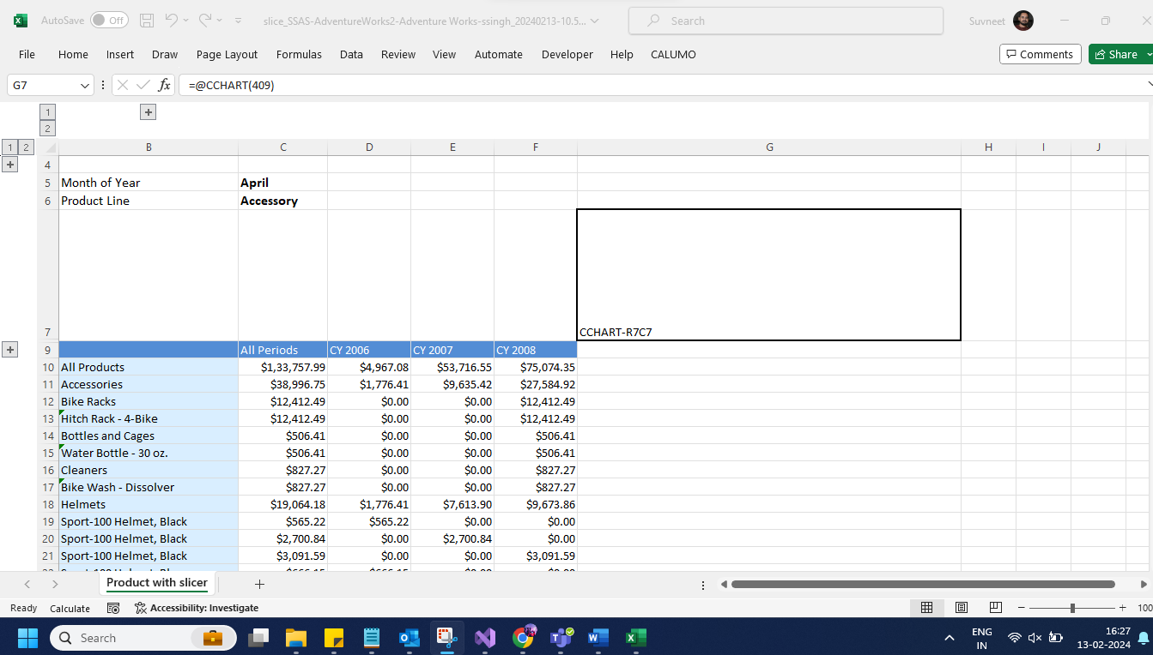
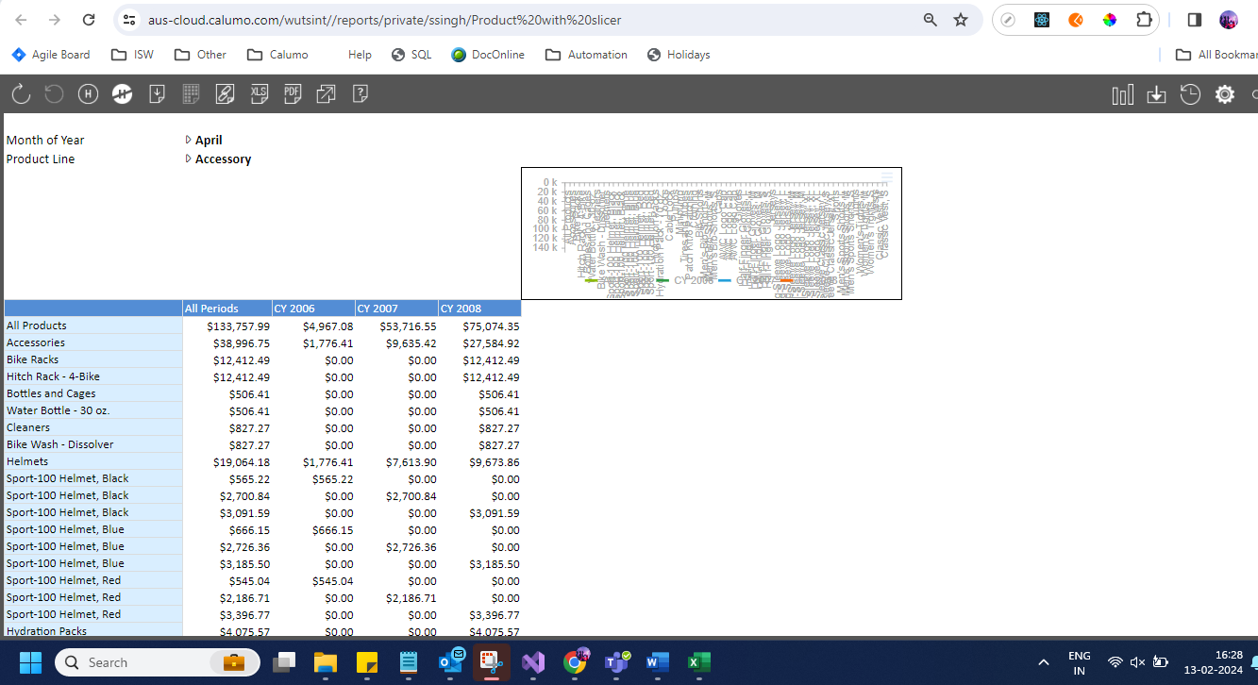

  - User should be able to drill down the view:
https://aus-cloud.calumo.com/wutsint/view?datasource=SSAS&catalog=ActiveCollab&cube=ActiveCollab&datasource=SSAS&catalog=ActiveCollab&cube=ActiveCollab&viewId=
https://aus-cloud.calumo.com/wutsint/drillThroughGrid?drillThroughCacheKey=338b6470-9dd7-c6fa-8c87-e5c0fda62931
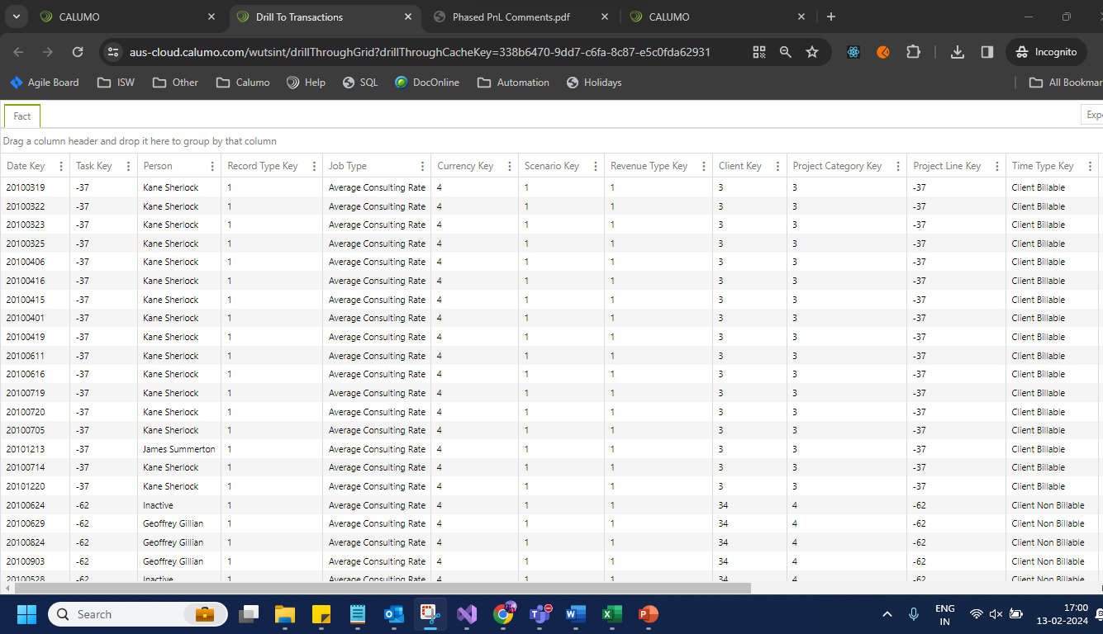

  - Able to convert view to private as well as public report:
https://aus-cloud.calumo.com/wutsint//reports/Product%20with%20slicer
Private report: https://aus-cloud.calumo.com/wutsint//reports/private/ssingh/Product%20with%20slicer
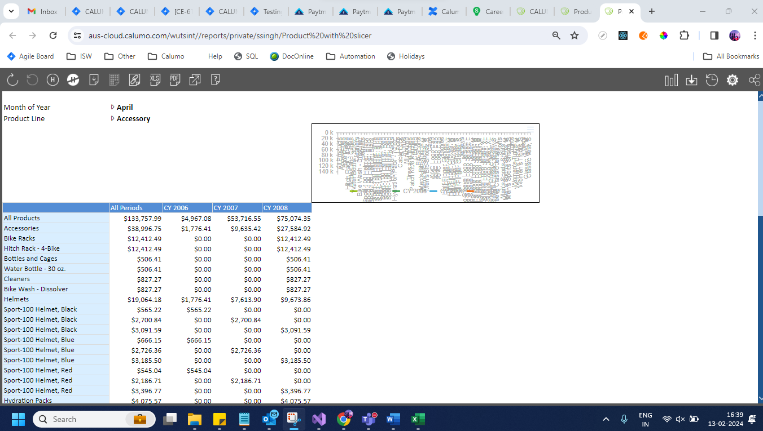
  - Able to see view along with chart:

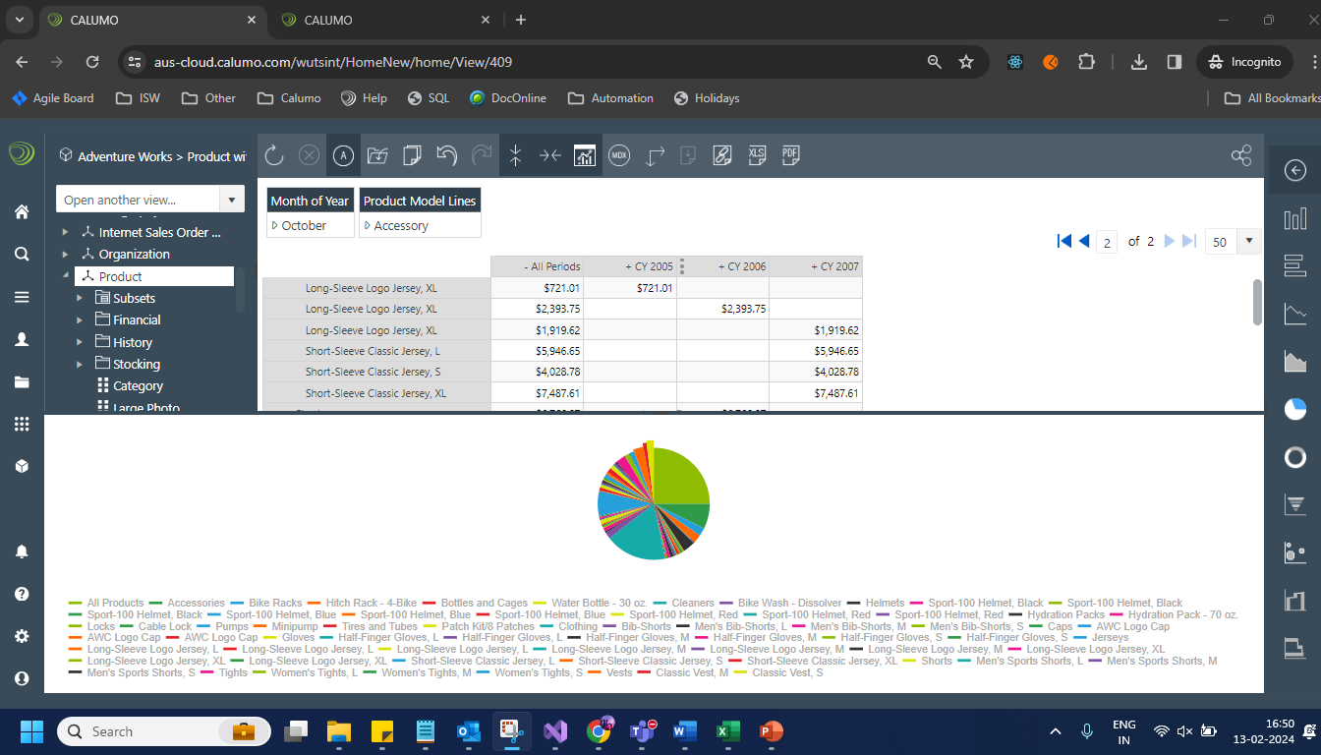

  - User should be able to see the Published report:
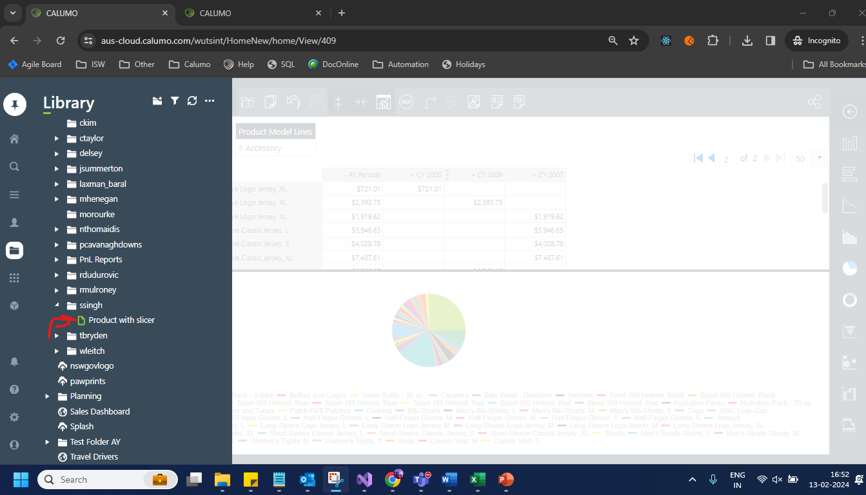
https://aus-cloud.calumo.com/wutsint/HomeNew/home/reports/Product%20with%20slicer

- APP tab:
User should be able to see the saved apps:
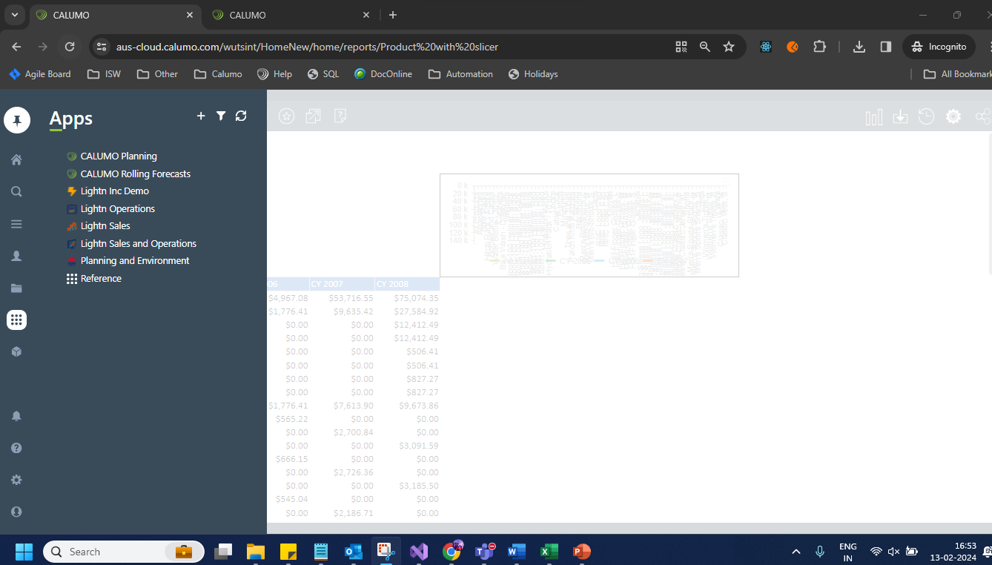

  - https://aus-cloud.calumo.com/wutsint/HomeNew/home/apps/Lightn%20Inc%20Demo
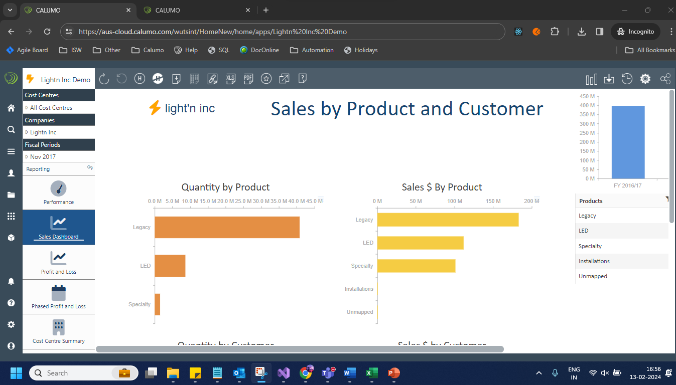
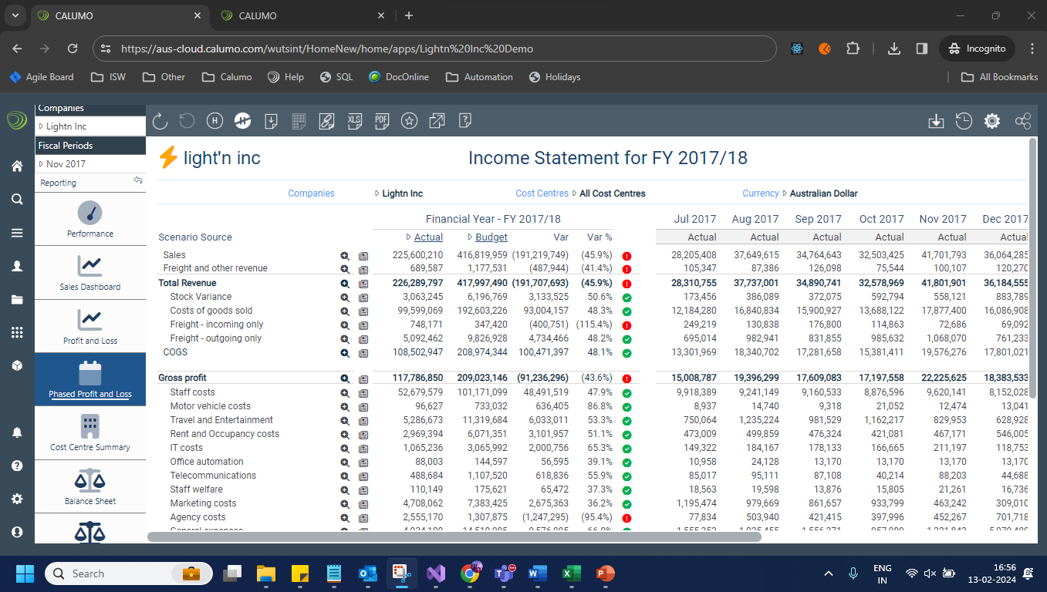

  - Able to download reports from Apps:

- Library tab:
User should be able to load report from library : https://aus-cloud.calumo.com/wutsint/HomeNew/home/reports/CC%20by%20Accounts%20Demo%202018

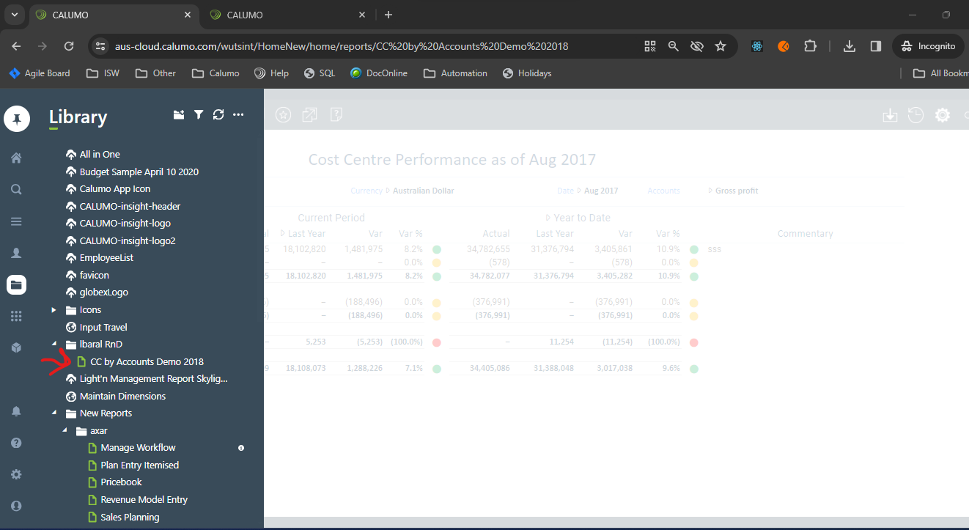

  - https://aus-cloud.calumo.com/wutsint/HomeNew/home/reports/Non-Financial%20Accounts%20List
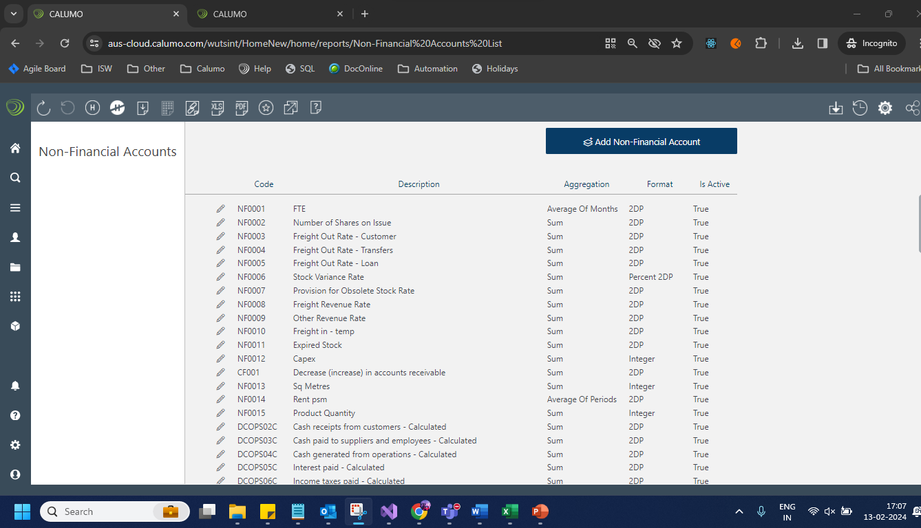

- Publication testing:
  - PDF publication:
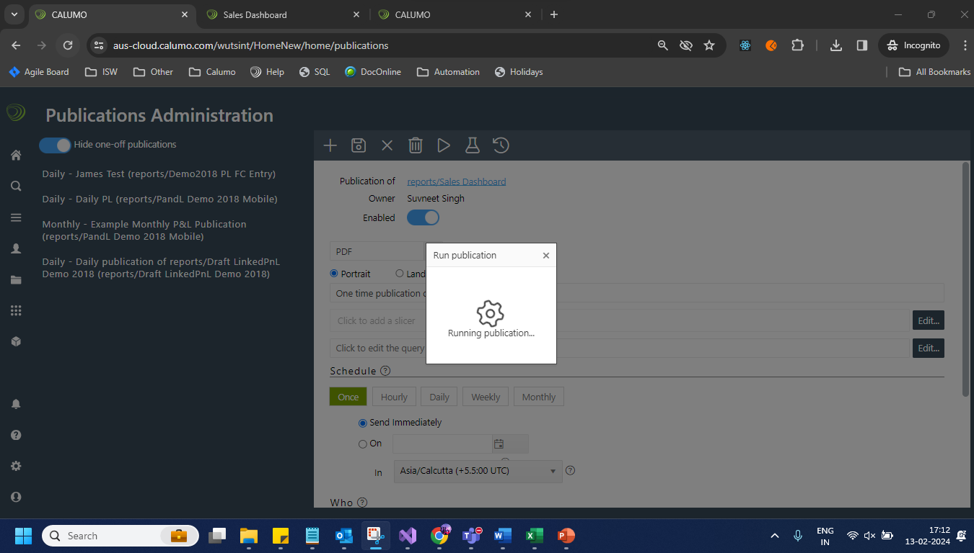
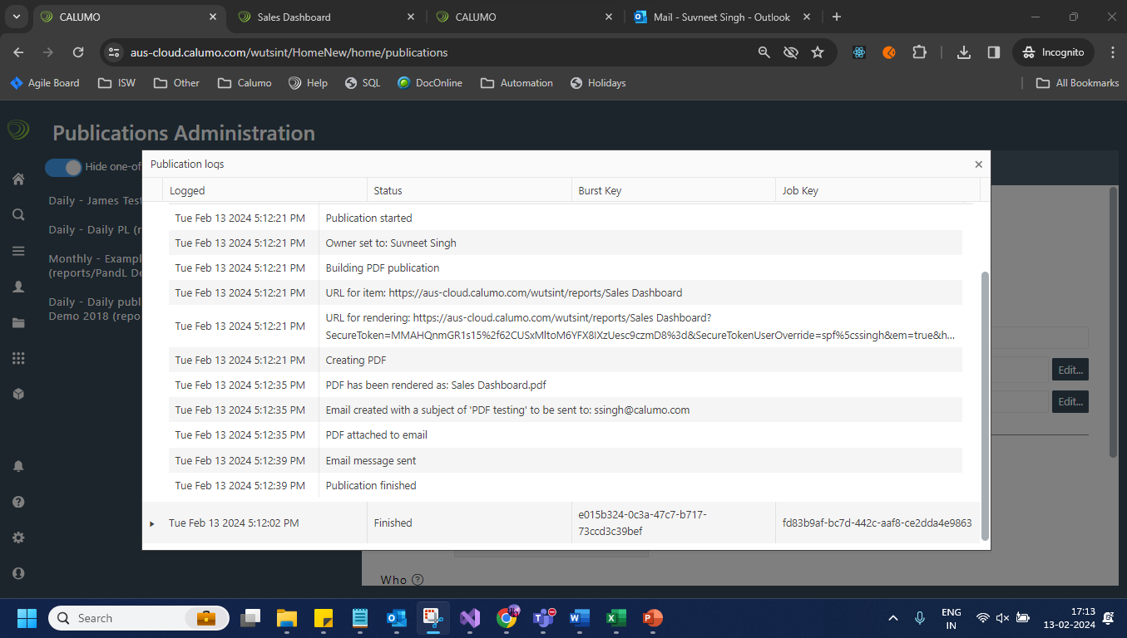

  - Excel publication:
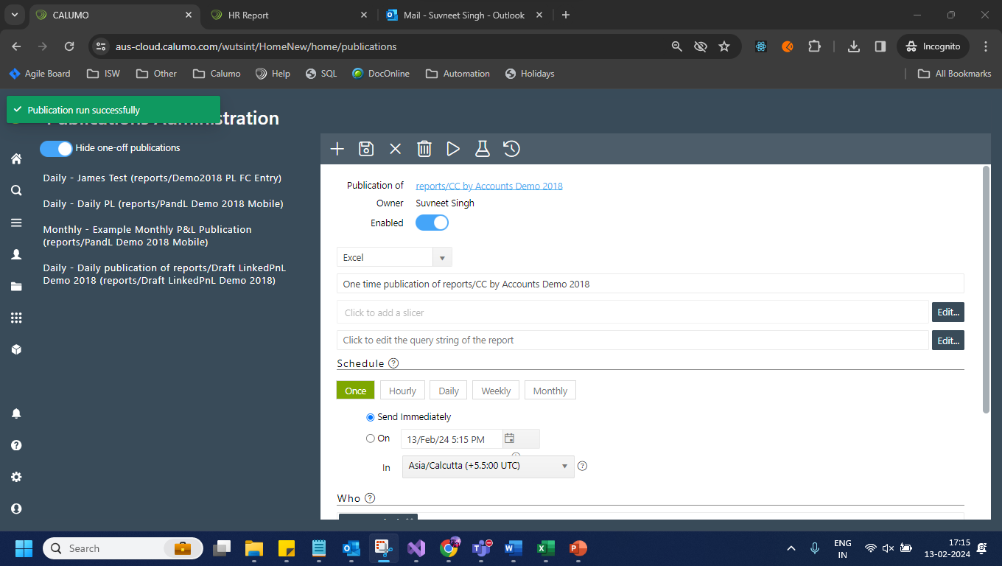
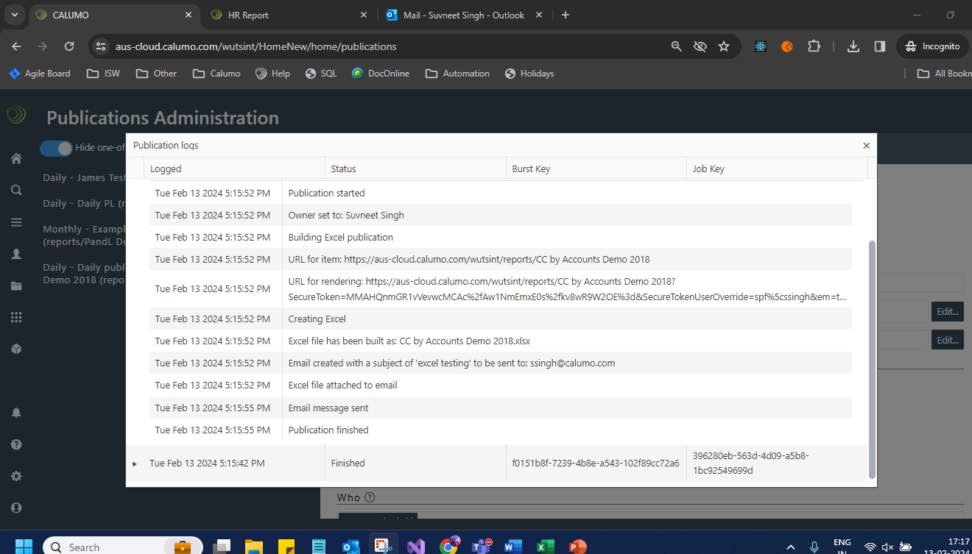
  - Excel As value publication:
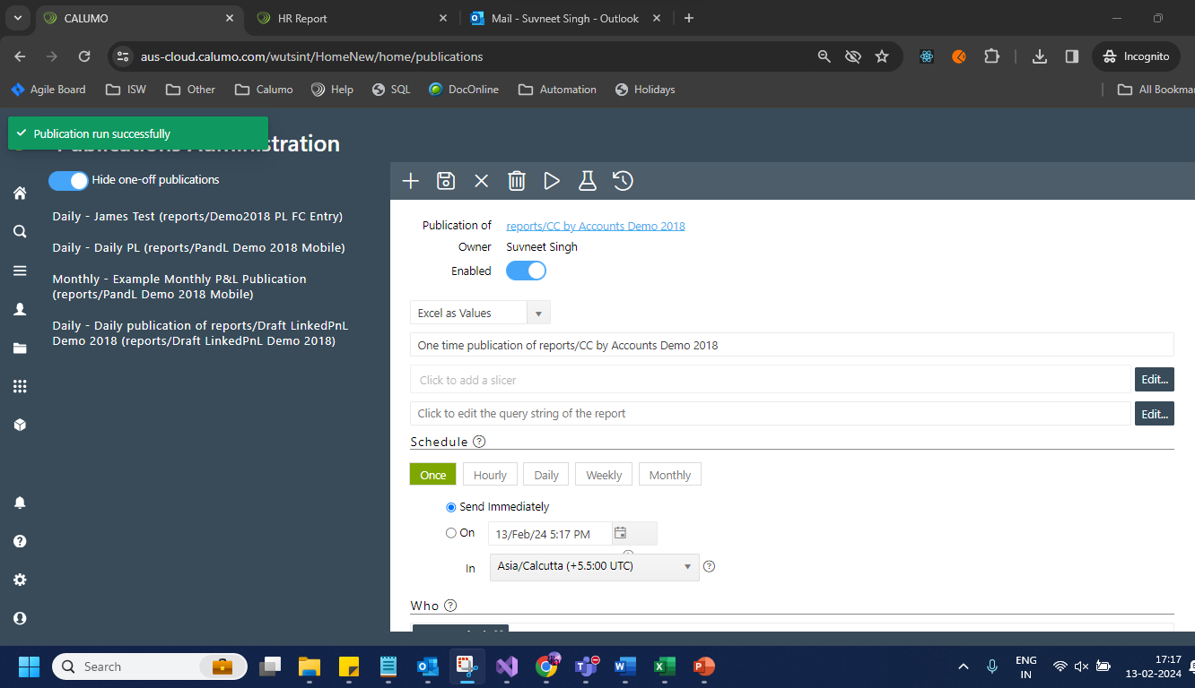
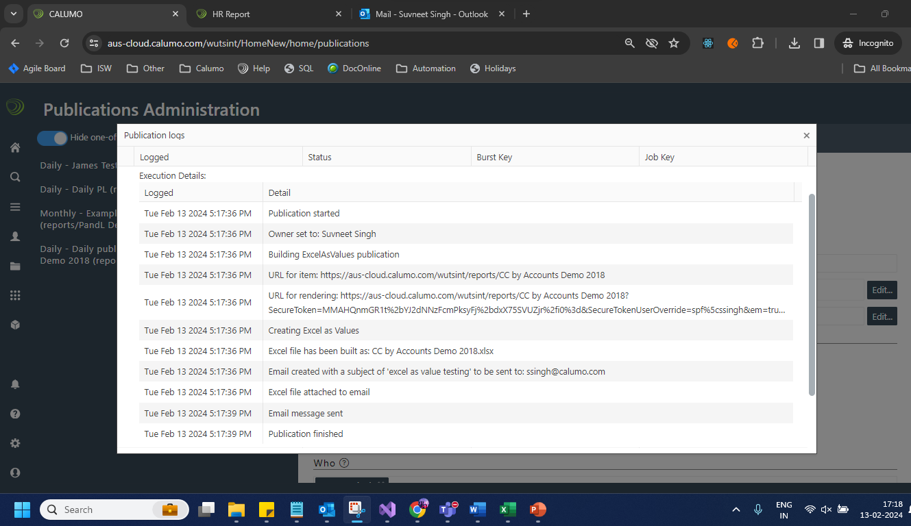
  - Image publication:
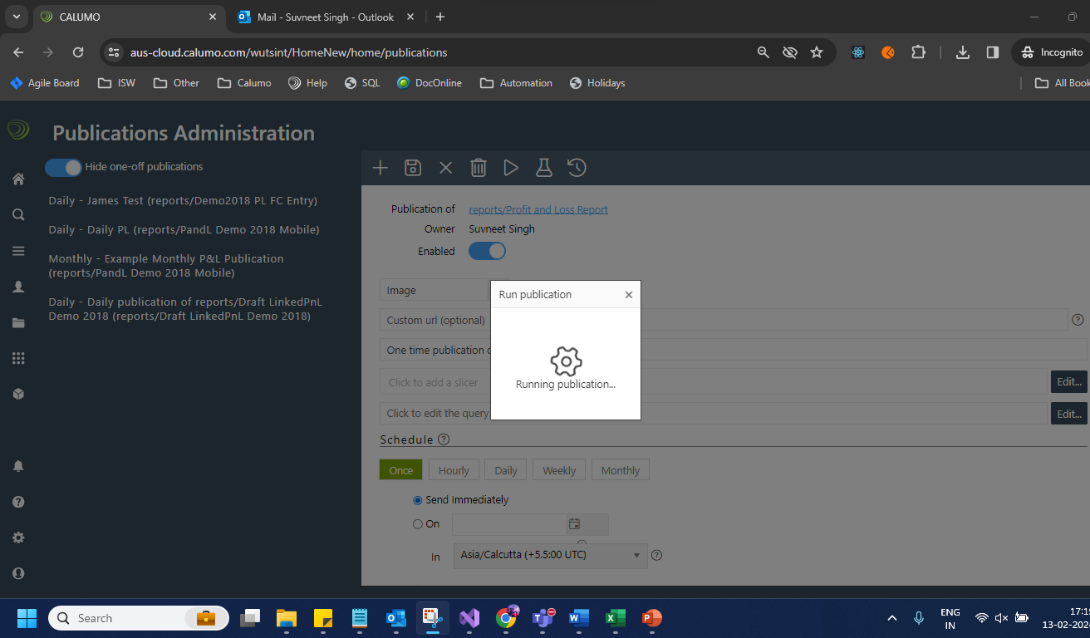

- Editable tables:
https://aus-cloud.calumo.com/wutsint/HomeNew/home/editable-tables

  - Opened any random editable table https://aus-cloud.calumo.com/wutsint/HomeNew/home/table-editor/index/Account
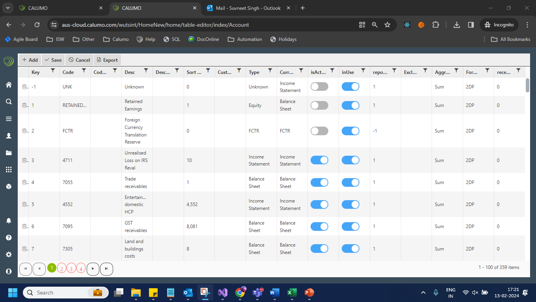
  - User should be able to add data in editable table: https://aus-cloud.calumo.com/wutsint/HomeNew/home/table-editor/index/Company
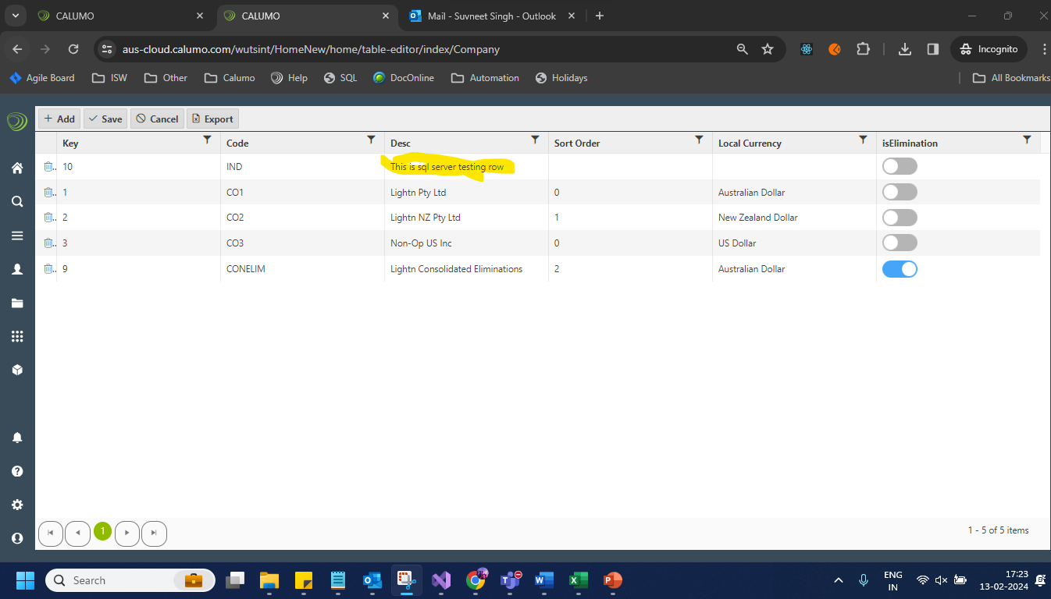

  - User should be able to delete data in editable table:
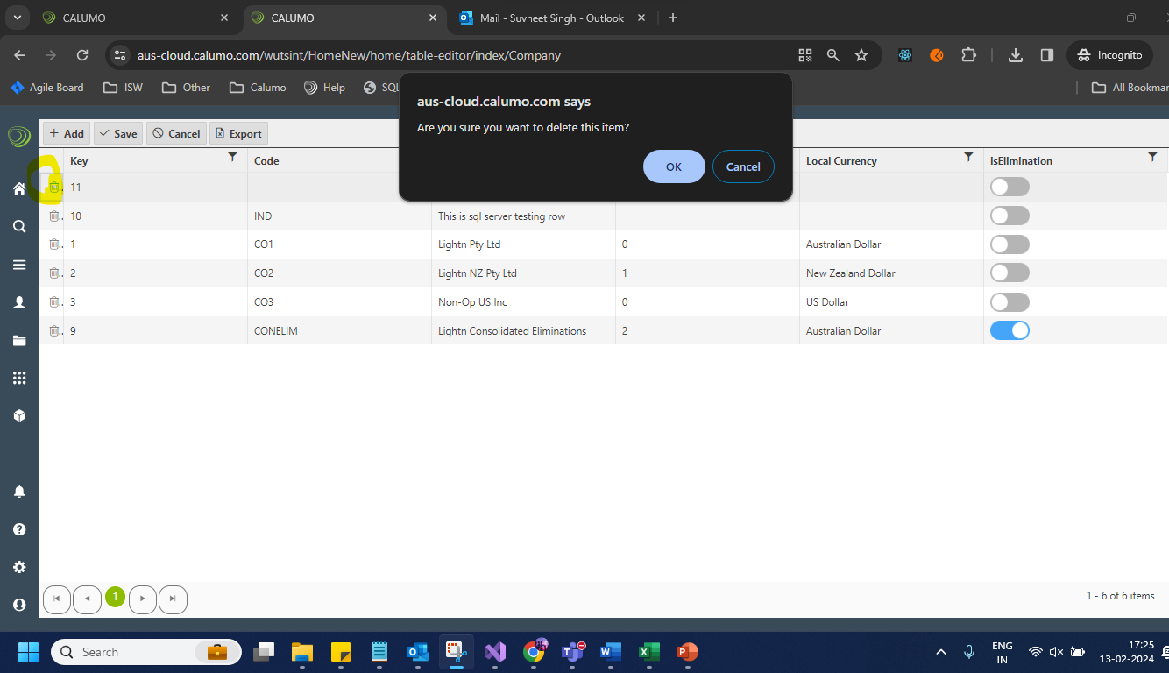
  - Post deletion:
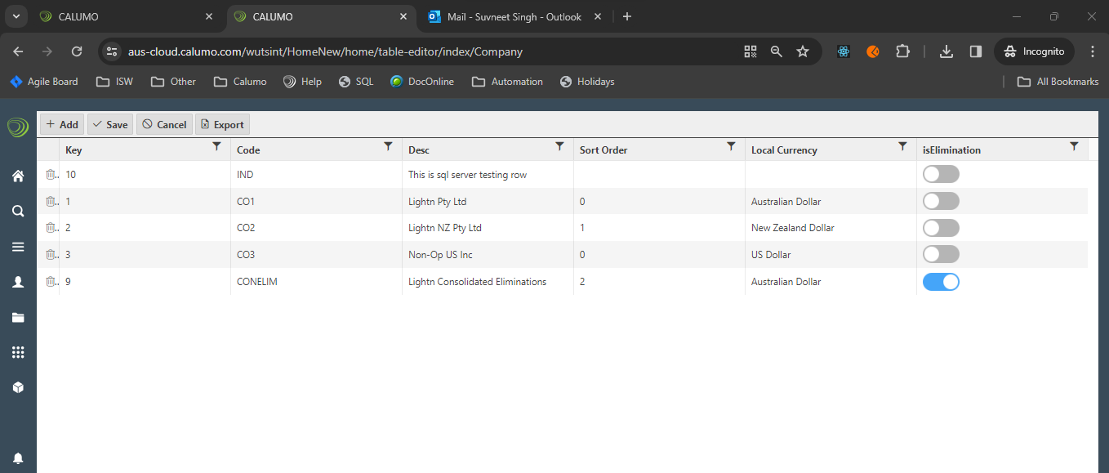

  - User should be able to download data from editable table:
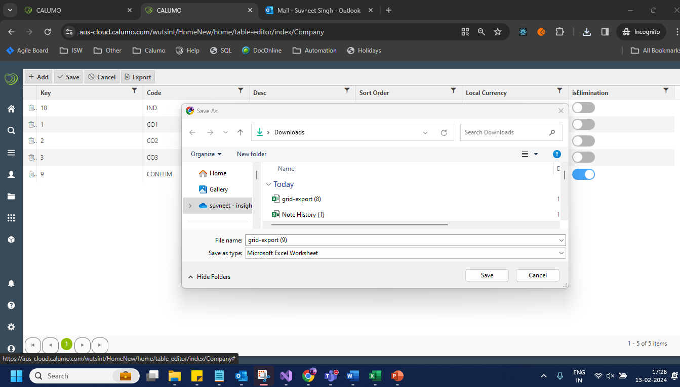

  - User should be able to update editable table:
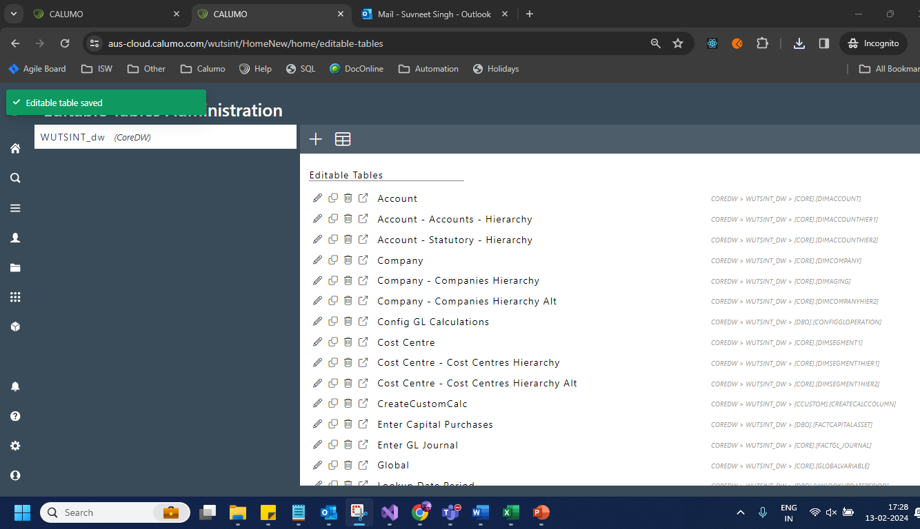
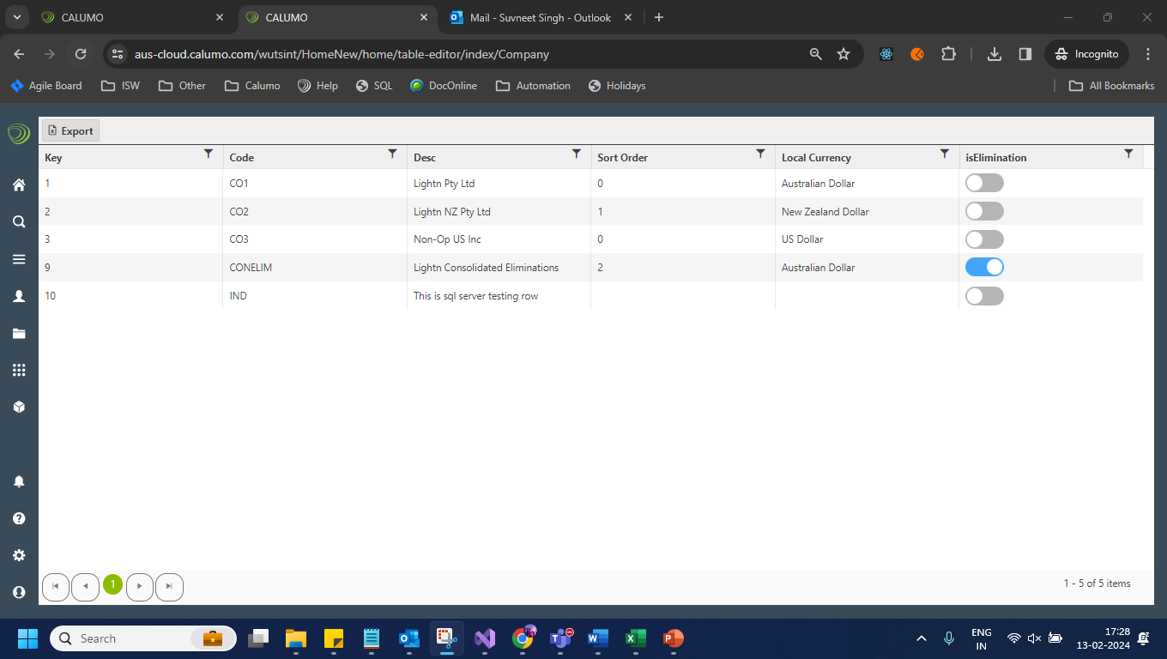
  - User should able to change data format of editable table:
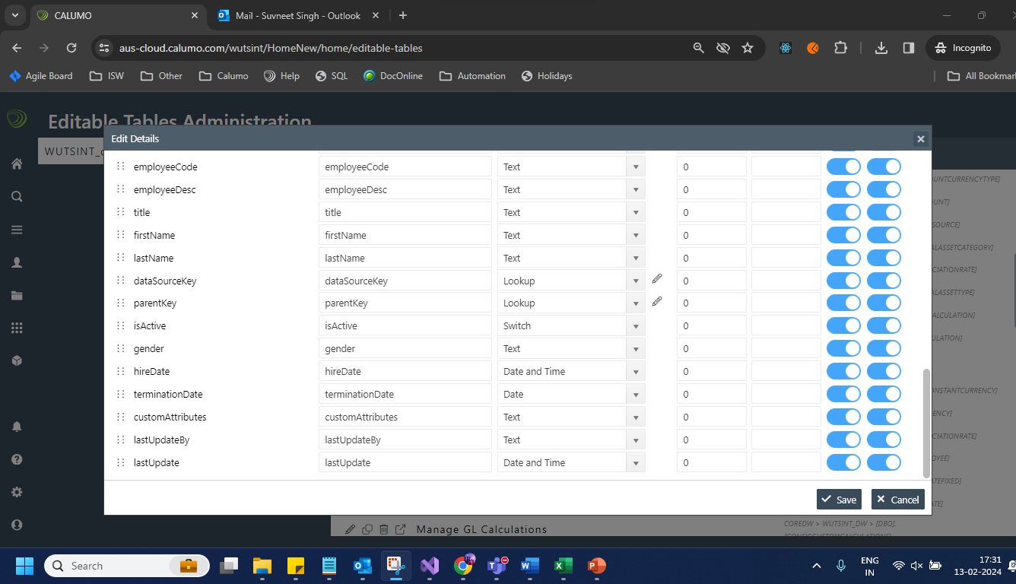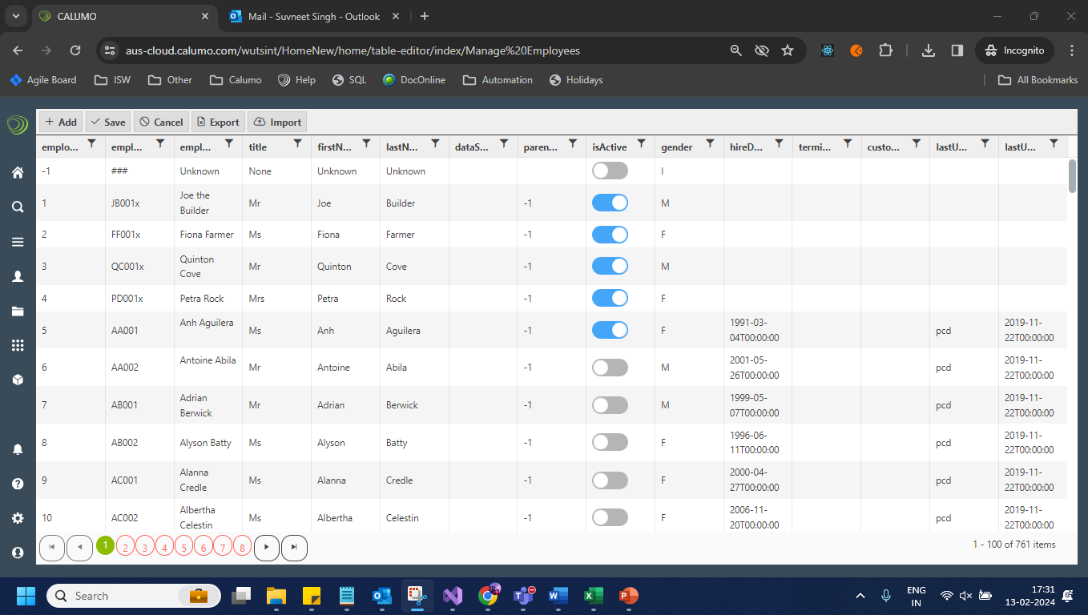

  - User should be able to clone the editable table:
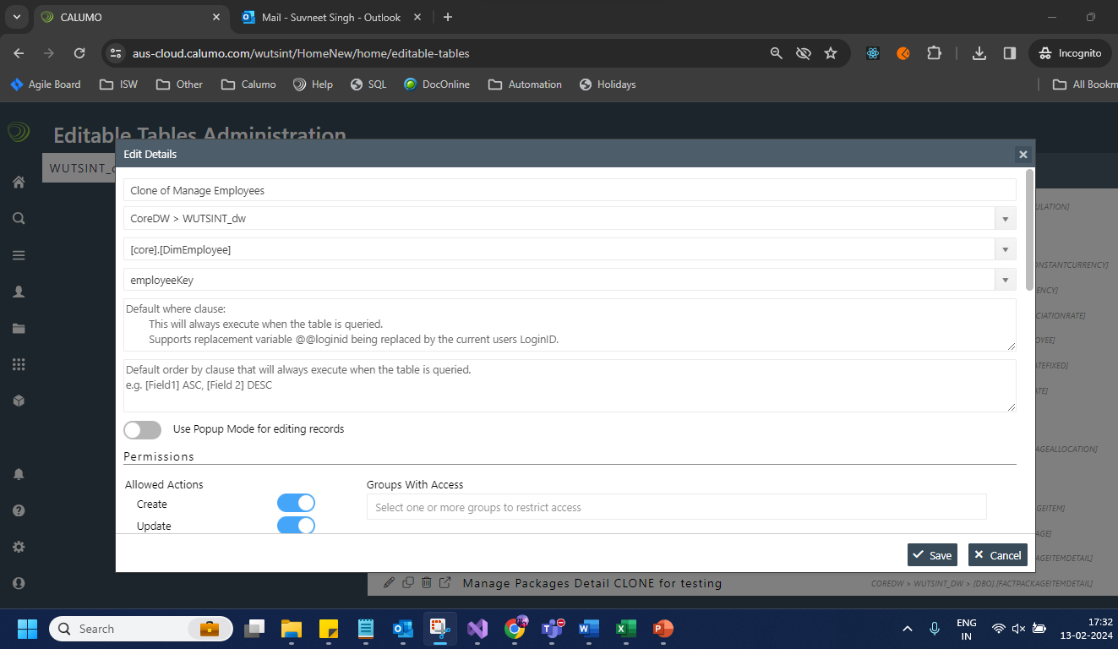
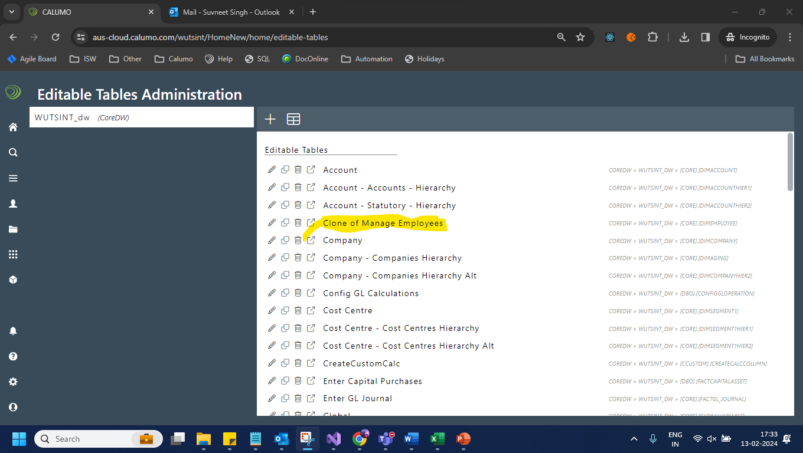
  - User can delete the editable table:
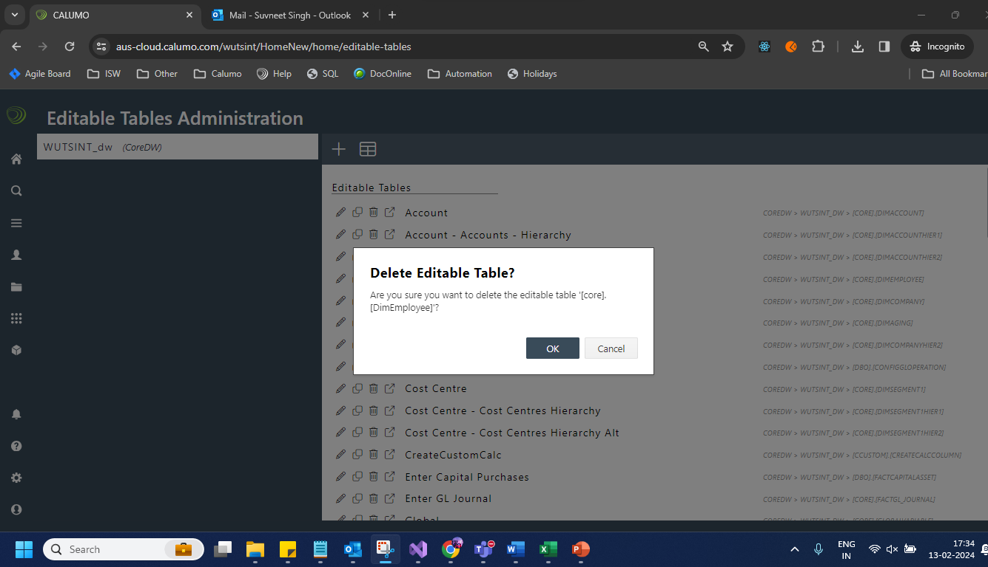
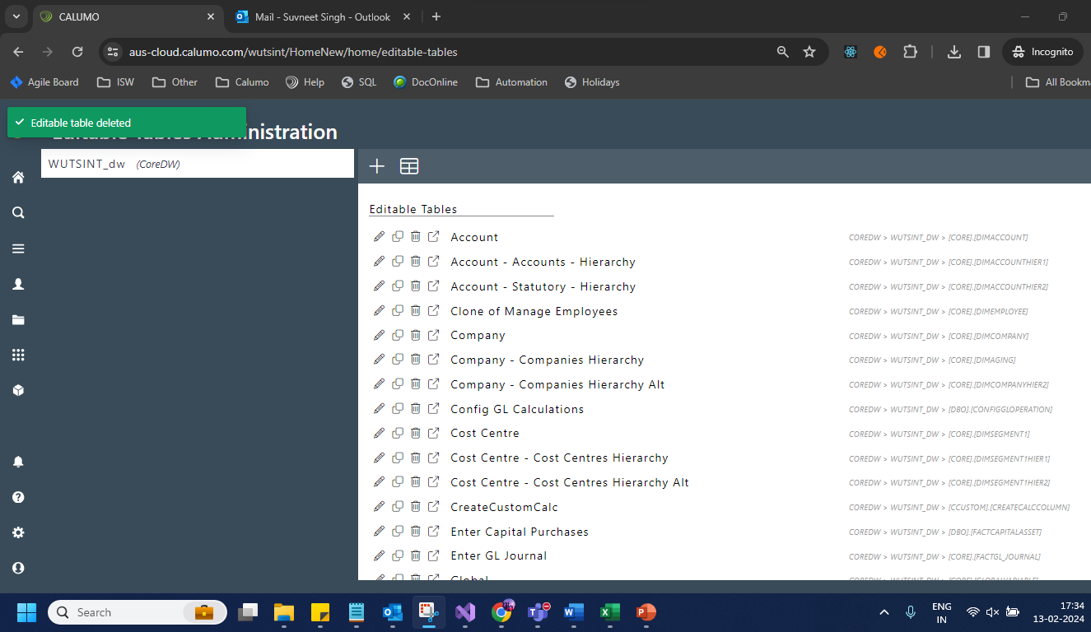
- Access control testing:
https://aus-cloud.calumo.com/wutsint/HomeNew/home/access-control
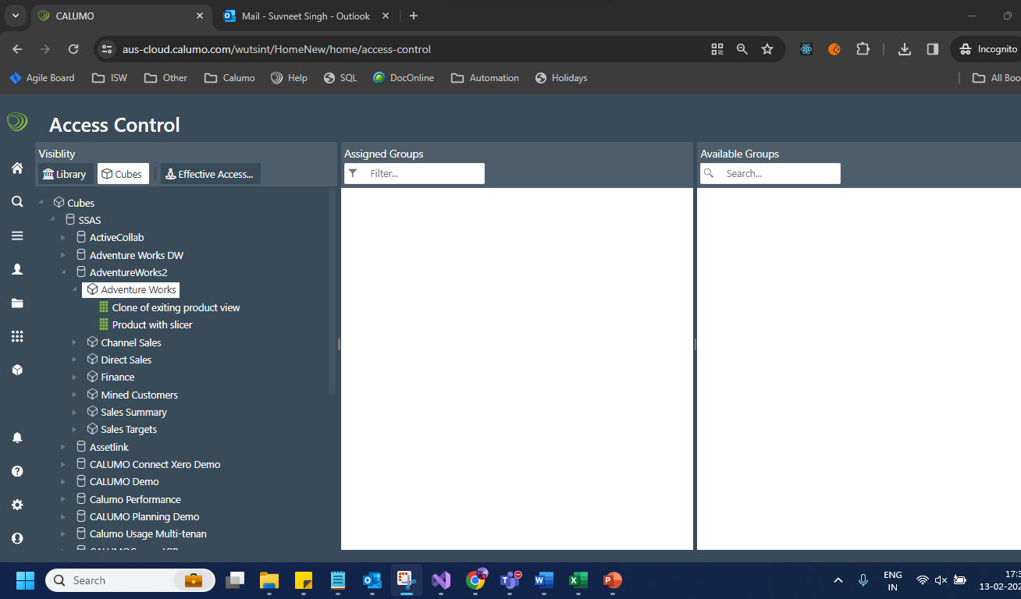
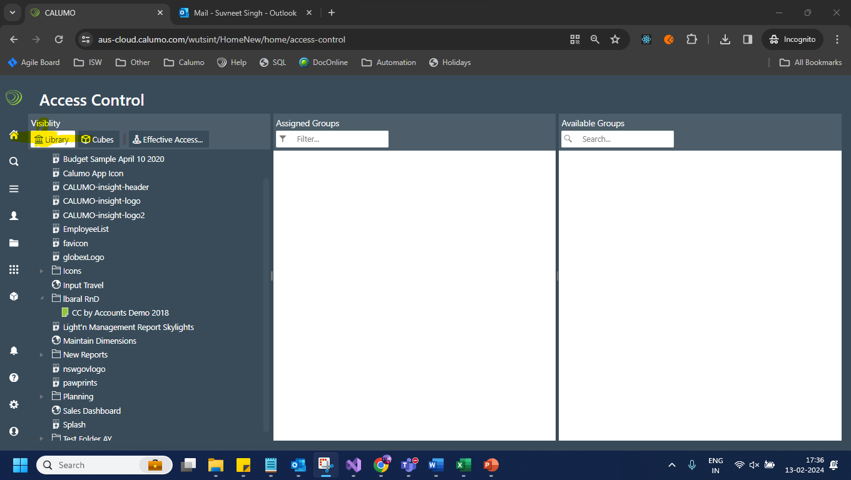

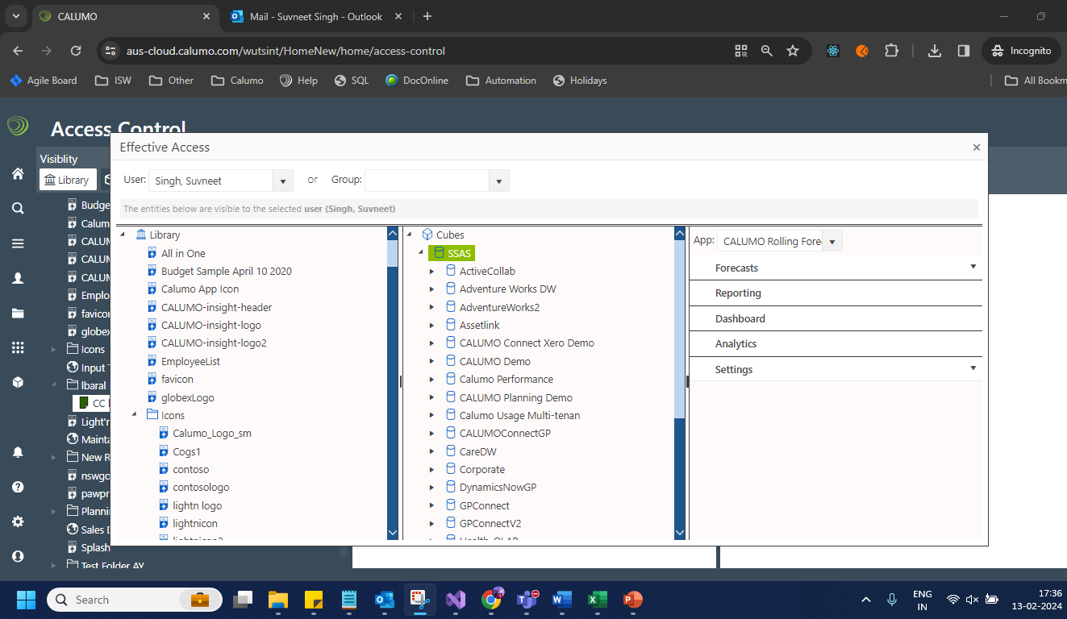

- Authorized procs:
https://aus-cloud.calumo.com/wutsint/HomeNew/home/authorized-procs
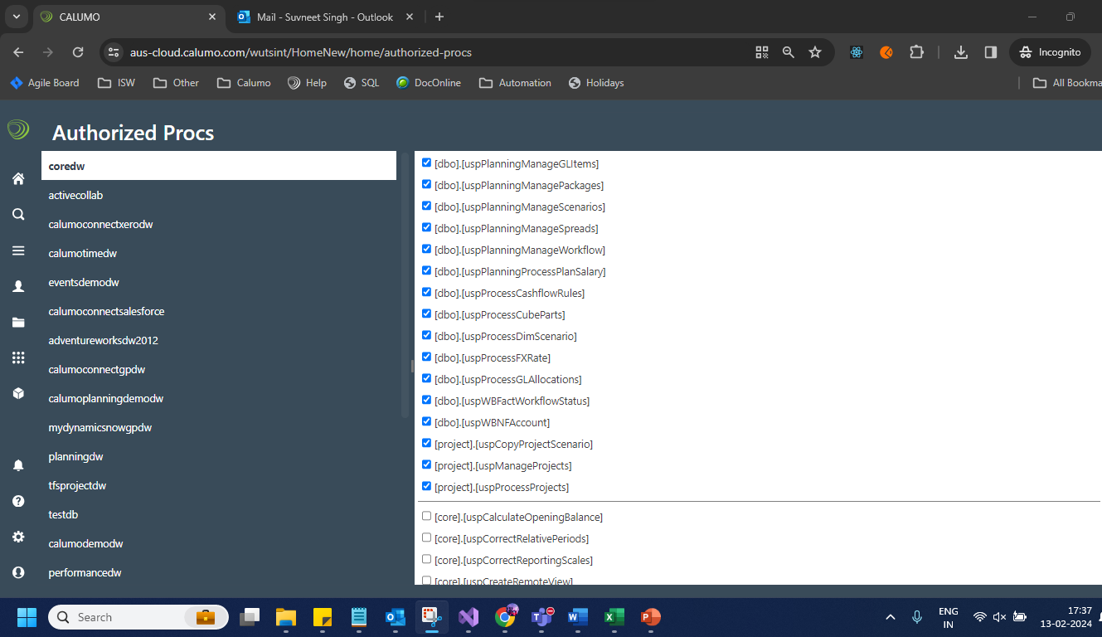

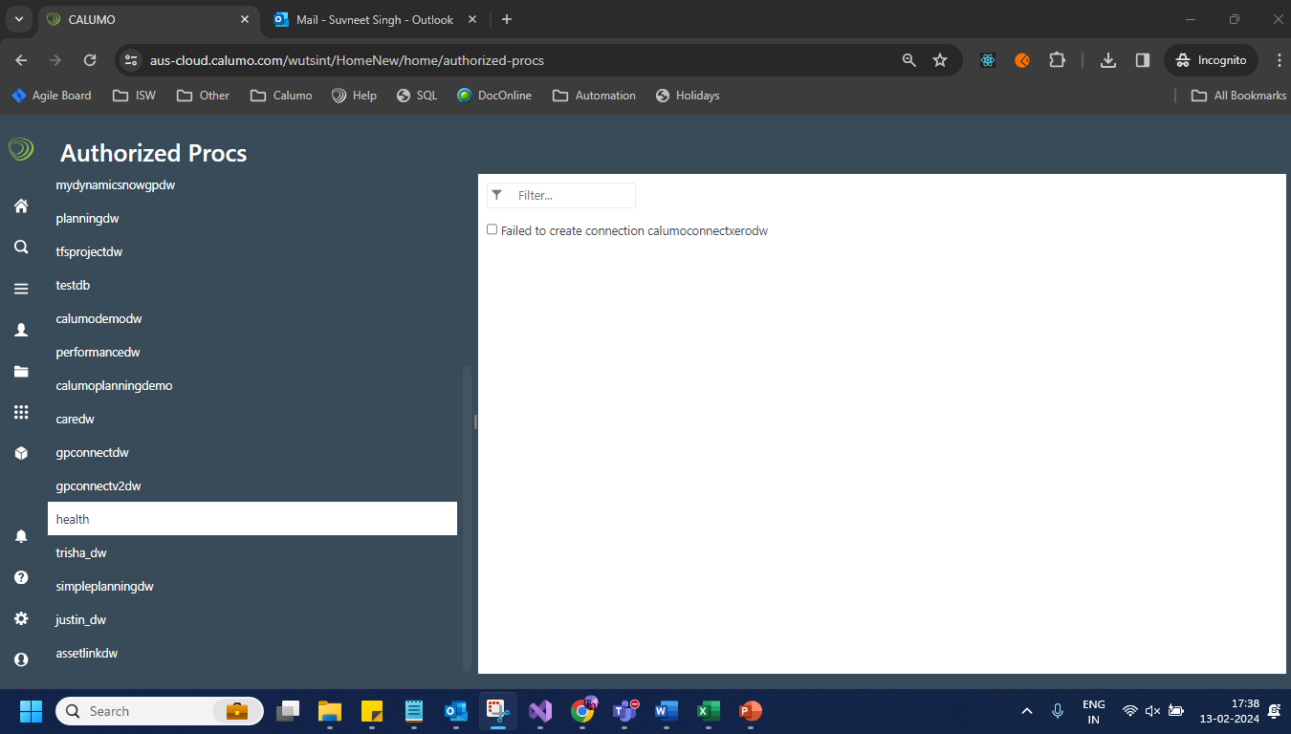

- Cube Events : https://aus-cloud.calumo.com/wutsint/HomeNew/home/cube-events

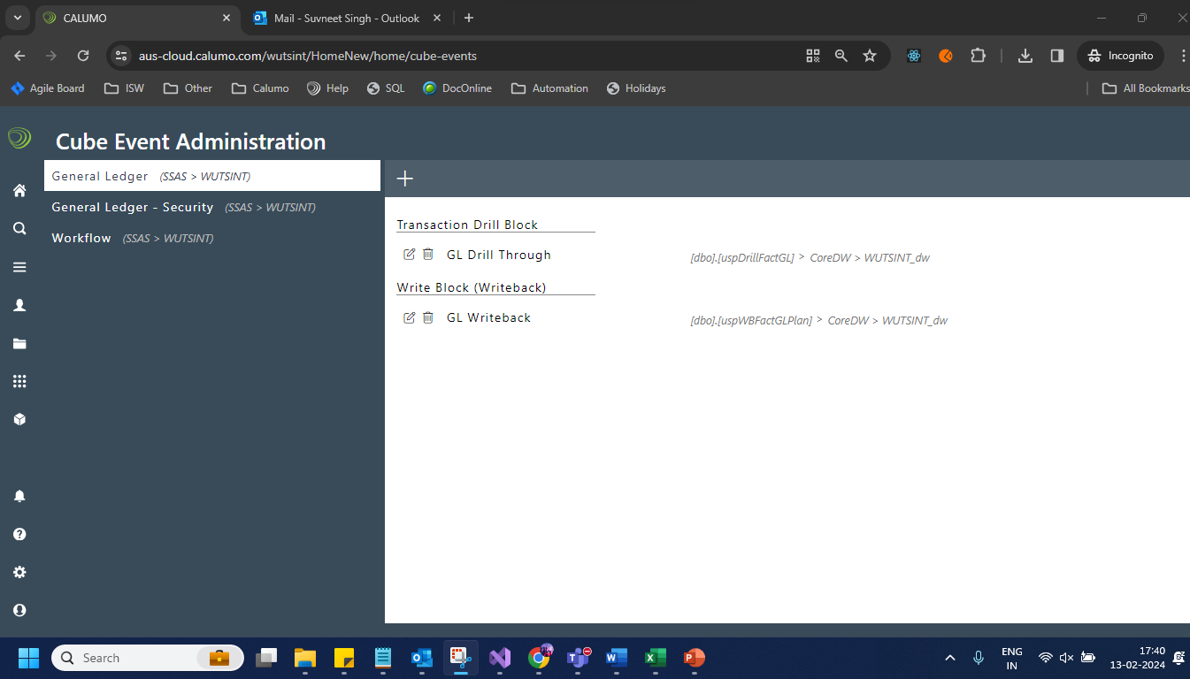

  - Dimension maintainers:
https://aus-cloud.calumo.com/wutsint/HomeNew/home/dimension-maintenance
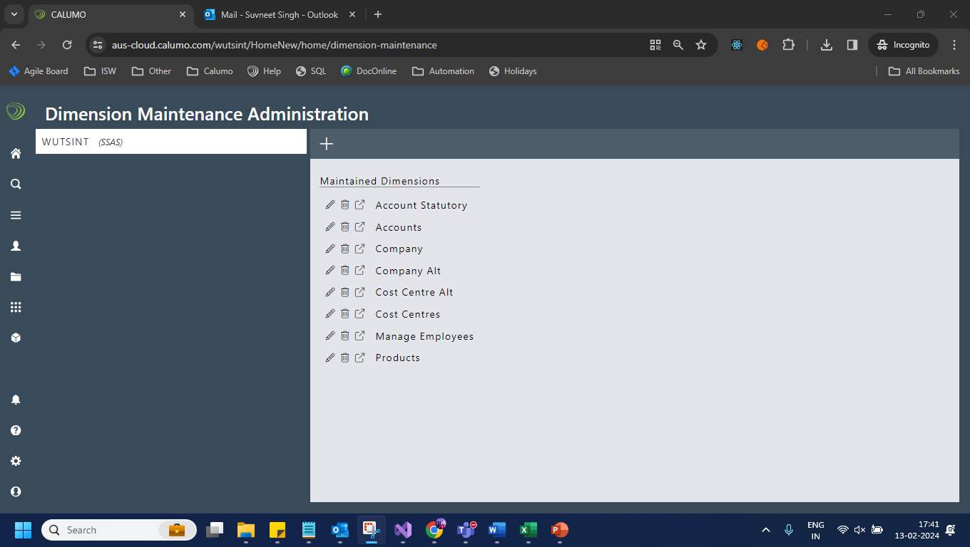

Report vault: https://aus-cloud.calumo.com/wutsint/HomeNew/home/report-vault
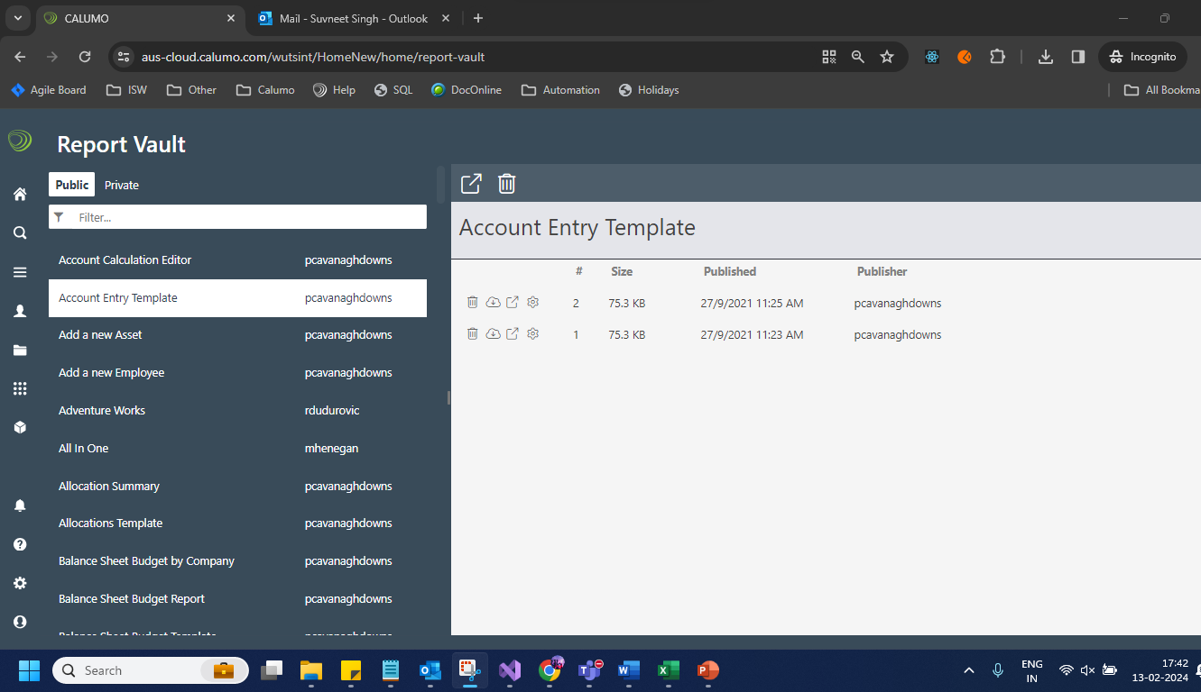
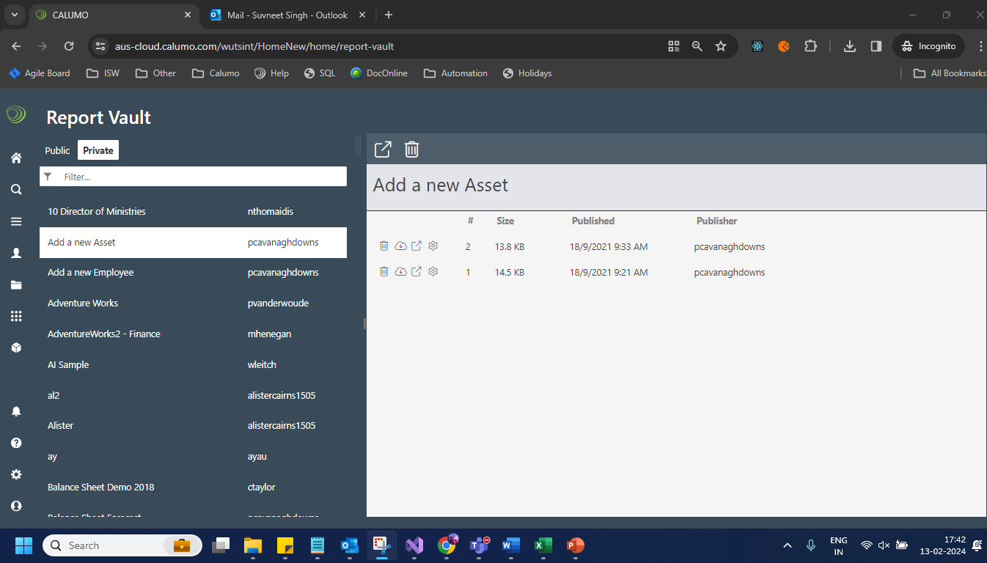

Overall Summary

The testing of CALUMO's compatibility with SQL Server 2022 indicates readiness for the transition, with performance enhancements and new feature benefits evidencing a strong case for upgrade. These findings support the testing prior to upgrade decision based on the test data and environments available. 2022 and 2019 are highly compatible, so the risk of encountering issues, based on research and testing results, is low. Based on the above activities and tests conducted in this environment, we do not have any reason to believe the upgrade will cause issues with the current client base. The scope of this testing has been limited to the detail and recommendations from Microsoft.

Care should be advised for larger and more complex CALUMO instances, with regression plans in place as required. The testing has not been exhaustive on all features across all instances, therefore, there may be cases that need to be addressed.

This testing outcomes were undertaken for review of upgrade to Microsoft SQL Server 2022 for CALUMO implementations as a guide to help Engineering in their testing processes. Technically, The SQL 2022 server testing scenarios did not reveal any adverse impacts on Application behavior. No code or configuration change requirement were identified.

